**CHAPTER -1**

**INTRODUCTION**

* 1. **INTRODUCTION**

Vehicle to everything (V2X) systems deals with the concept of Internet of Vehicles (IoV) wherein the connection of internet to vehicles enables information sharing and collection of information on vehicles and infrastructure. In this paper, a dedicated WLAN based system is developed to support vehicle-to-vehicle (V2V), vehicle-to-infrastructure (V2I) and vehicle-to-pedestrian (V2P) communication for the safety of vehicles and pedestrians. MQTT protocol is used to provide communication to V2X architecture. It works on publish-subscribe technique such that the controllers embedded in the vehicles and infrastructure elements can be subscribed to different topics depending on the relevant information to be transmitted. Cloud based MQTT brokers allows the devices to connect to their own network to establish communication between the various V2X components within the specified range. Raspberry pi acts as a monitoring device which gives information regarding the traffic congestion as well as provides V2P functionality.

With rising interest in autonomous vehicles, developing reliable and low latency vehicular communications has become of paramount importance. Vehicle-to-Everything (V2X) refers to an intelligent transport system where all vehicles and infrastructure systems are interconnected with each other [1]. V2X communication is the passing of information from a vehicle to any entity that may affect the vehicle, and vice versa. It is a vehicular communication system that incorporates other more specific types of communication as V2I (vehicle-to-infrastructure), V2N (vehicle-to-network), V2V (vehicle-to-vehicle), V2P (vehicle-to-pedestrian), V2D (vehicle-to-device) and V2G (vehicle-to-grid). V2X technology enables vehicles to automatically pass along messages regarding road conditions, traffic flow, and obstacles before these appear in the driver's visual range. This connectivity will provide more precise knowledge of the trafﬁc situation across the entire road network which in turn will help optimize trafﬁc ﬂows, reduce congestion, cut accident numbers and minimize emissions.

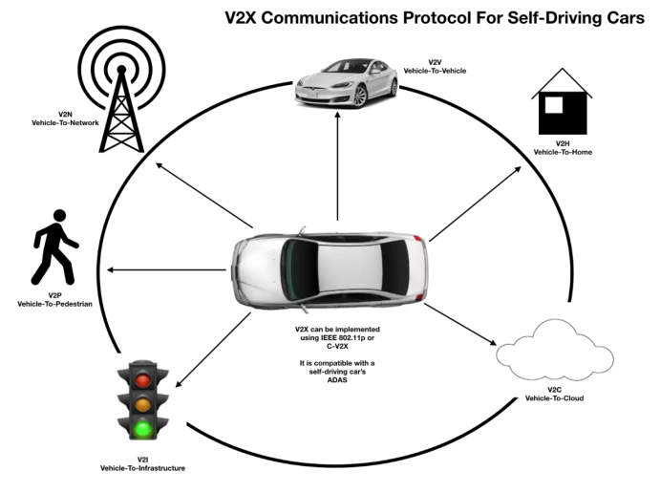

Fig 1.1: V2X Communication Protocol for Self-Driving Cars

Vehicle-to-cloud refers to the ability of the vehicle to connect to a cloud and access pertinent data for the completion of the task or request [2]. A cloud refers to the generalized delivery of services hosted over the Internet, allowing the consumption of computer resources, like virtual machines, storage, or software applications. By utilizing cloud services, vehicles are provided with the ability to access real-time data on information that are relevant to the situation in which the drivers of the vehicle may find themselves. As this data is provided to the owners of the vehicles, big data is collected from those vehicles on the traffic patterns and other concerns surrounding the vehicle, using that information to be able to provide other passing vehicles with similar information on traffic patterns. Vehicle-to-cloud communication offers the functionality to link vehicles and other gadgets through the cloud without affecting security. Vehicles are securely linked with the help of a bi-directional communication link that supports multiple protocols as well as interfaces like: MQTT, CoAP and HTTP.

Vehicle-to-vehicle (V2V) communications refers to the transmission of data between two vehicles using wireless communication. V2V comprises a wireless network where automobiles send messages to each other with information about what they’re doing. This data would include speed, location, direction of travel, braking, and loss of stability. The ultimate goal of this particular type of technology is to provide the driver with real-time updates to prevent accidents on the road through the communication of aforementioned data across a wireless network. The result would either be a notification to the driver or the on-board computer to implement evasive manoeuvres that prevent accidents. Vehicle connectivity with mobile apps have the great potential to offer a better driving experience, by providing information regarding the surrounding vehicles and infrastructure and making the interaction between the car and its driver much simpler.

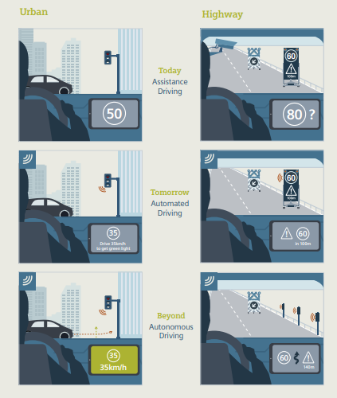

Fig 1.2: Cooperative Infrastructure Systems

Vehicle-to-Infrastructure (V2I) communication is the wireless exchange of data between vehicles and road infrastructure. Vehicle-to-infrastructure is a feature that allows vehicles to communicate with infrastructures, such as the municipal traffic system to realize an intelligent prediction solution regarding traffic conditions. Enabled by a system of hardware, software, and firmware, V2I communication is typically wireless and bi-directional. Infrastructure components such as lane markings, road signs, and traffic lights can wirelessly provide information to the vehicle, and vice versa. One use case where this technology uses the advantage of V2I is to avoid drivers from waiting for lights changes by giving them the real-time updates. This informs the drivers the length of time they will spend at intersections.

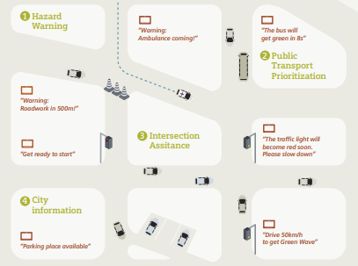

Fig 1.3: V2I Schematic

Vehicle-to-Pedestrian (V2P), refers to the ability of an individual other than the owner/operator of the vehicle to be able to use the vehicle as a wireless hotspot. The primary purpose behind this connectivity is to increase the safety of pedestrians, allowing vehicles to transmit safety warnings to pedestrians and decrease the likelihood of an accident. The goal is to ultimately be able to use this technology to effectively communicate the speed, location, and trajectory of a vehicle to a pedestrian’s connected device as a means of decreasing the likelihood of an accident.

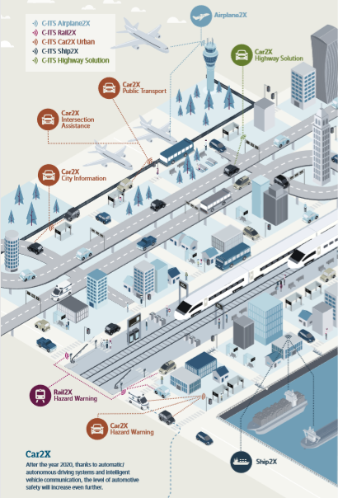

Fig 1.4: ITS Schematic

Message Queue Telemetry Transport (MQTT) is a simple protocol that lets an embedded device publish/receive messages in the cloud. The MQTT publish/subscribe system consists of many clients, which are connected to a server acting as a broker. A client is both the producer and consumer of MQTT data. MQTT has minimal packet overhead compared to protocols like HTTP and is therefore very efficient, lending itself to low-power environments. MQTT protocol is used to provide communication to the V2X architecture. MQTT provides suitable communication in real time scenario with a latency of ±2s.

* 1. **OVERVIEW**

Vehicle-to-vehicle and vehicle-to-infrastructure communication (V2X communication) has great potential to increase road and passenger safety, and has been considered an important part of future Intelligent Transportation Systems (ITS). Several R&D projects around the world have been investigating various aspects of V2X communication. Some of these projects focus on specific issues of V2X communication for intersection safety (communication-based intersection safety) because intersections are the most complex driving environments where injury and fatal accidents occur frequently. In this paper, we discuss the technical details of V2X communication and discuss how it can be used to improve intersection safety. Vehicle to everything architecture (V2X) will provide precise knowledge of the traffic situation across the entire road network which in turn will help in optimizing traffic flows, reduce congestion, cut accident numbers, improve pedestrians’ safety and minimize emissions.

* 1. **MOTIVATION**

As vehicles gain extensive popularity, traffic accidents involving vehicles as well as vulnerable pedestrians are on the rise at alarming levels. As indicated by the World Health Organization (WHO), consistently the lives of roughly 1.35 million individuals are lost because of road traffic accident [3]. Somewhere in the range of 20 and 50 million additional individuals endure non-lethal wounds, with many bringing about a disability because of their damage. Street mishap insights in India gauge that more than 1,37,000 individuals were killed in street mishaps in 2013 alone, with roughly one death every four minutes [4]. Majority of these accidents happen due to distracted driving and driver negligence. In addition to this, surveys conducted by the European Union (EU), in 2013, conclude that Road traffic accounts for 1/5 of the total CO2 emissions in Europe wherein traffic congestion costs about 1% of its GDP every year. The main motivation is to upgrade street wellbeing, lessen mishaps, increase safety, efficiency and reduce traffic jams.

* 1. **NEED OF THE PROJECT**

Vehicle-to-Everything (V2X) communication holds the promise for improving road safety and reducing road accidents by enabling reliable and low latency services for vehicles such as forward collision warning, road safety services and emergency stop. Vehicle-to-Everything (V2X) communication has a crucial role for enabling reliable and low latency services for vehicles such as forward collision warning, road safety services and emergency stop. Vehicles are among the fastest growing type of connected devices . Therefore, there is a need for improving the existing Long Term Evolution Advanced (LTE-A) communication. This is particularly relevant for V2X communication, which is an important feature of LTE Release 14.

To support safety-related and non-safety-related messages, the wireless technologies used in V2x communication need to do several things. They need to operate in a very dynamic environment with high relative speeds between transmitters and receivers, and they need to support extremely low latency in the safety-related applications (50 ms for the “pre-crash sensing warning message”, see Table I). They also need to tolerate the high load generated by the periodic transmission of multiple messages by multiple actors, and the high vehicle density typical of congested traffic scenarios. Another consideration is that V2x messages are local in nature, meaning they are most important to nearby receivers. For example, a “pre-crash sensing warning message” is extremely relevant for the vehicles in the surrounding of the crash, but irrelevant to far-away vehicles

**1.5 APPLICATION AND USE CASES**

In this section, we discuss several use cases for communication-based intersection safety that can be supported by V2X communication. Some of these use cases have been identified by the pioneering projects reviewed in Section 2. While the use cases discussed here are not meant to be comprehensive, we believe that they are representative for communication-based intersection safety.

**Prevention of traffic light violation -** In this use case, an infrastructure-based intersection assistant can use V2X communication to inform approaching vehicles about the traffic light’s status and the remaining time until the status changes. Since a traffic light system is inherently complex and involves many inputs such as inductive loops and push buttons for pedestrians, traffic light can change unpredictably. For this reason, real-time V2X communication is necessary to provide vehicles with accurate and up-to-date signal phase of a traffic light. Given a traffic light’s status, a vehicle can deliver a warning to a driver when a potential traffic light violation is detected. Further, the vehicle can also adjust its velocity to achieve optimized fuel consumption. This use case can be supported efficiently by GeoBroadcast or Topologically-Scoped Broadcast forwarding.

**Prevention of turning and crossing-path collision** - This use case assists drivers in their turning or crossing-path maneuvers at an intersection. Sensors installed at an intersection can detect objects and vehicles and construct an overview of the intersection. This view can be broadcast at a regular interval on the wireless channel to inform a driver about the presence of other road users at an intersection. Further, V2X communication can be used as an enabling technology for cooperative fusion of sensor data acquired in vehicles and at the infrastructure side. Cooperative data fusion provides a driver with a better vision of an intersection and helps detect other road users that the driver would overlook due to obstacles, distraction, or bad weather. Special protection for vulnerable road users (VRUs) can be obtained. This use case can be supported efficiently by GeoBroadcast or Topologically-Scoped Broadcast forwarding.

**Prevention of rear-end collision** - This use case prevents an accident from happening when a vehicle reduces its velocity abruptly at an intersection and other vehicles behind it do not have sufficient time to react. In this use case, multi-hop V2X communication can distribute a message within an intersection’s surrounding area to warn other drivers [5]. The warning message can be triggered by a vehicle’s braking system or infrastructure-based sensors. Further, the traffic light controller can use V2X communication to inform drivers about the recommended driving speed before they enter an intersection. With this information, drivers can avoid reducing their speed abruptly at an intersection. This use case can be supported efficiently by GeoBroadcast or Topologically-Scoped Broadcast forwarding.

**Traffic signal adaptation for emergency warning and prioritized road users** - This use case can provide a dynamic traffic signal adaptation when an accident occurs at an intersection. In this case, an intersection assistant can broadcast an alert on the wireless communication channel. Further, in case a vehicle causes an accident, it can also send an emergency message to the infrastructure to trigger an all-red traffic light and prevent other vehicles from entering the intersection until the situation becomes clear. In emergency scenarios, an intersection can also support prioritized road users, e.g., emergency vehicles by giving them the green light in their direction. This use case can be supported efficiently by GeoBroadcast or Topologically-Scoped Broadcast forwarding.

**Traffic efficiency -** In this use case, RSUs can monitor road conditions and traffic density at intersections and provide a backend traffic management center with real-time information. Using this information, the traffic management center can obtain a global view of road systems and can compute alternate routes for vehicles. The traffic management center sends this information back to RSUs to inform the drivers. Drivers can use this information to optimize their route selection according to their needs. This use case can be supported efficiently by GeoBroadcast or Topologically-Scoped Broadcast forwarding.

**1.6 LIMITATIONS**

* As vehicles in V2X are connected to internet, they are prone to hacking. Hackers can access and control the vehicle.
* Privacy of the owners and users of the vehicles are major concern. This is due to leakage of information such as vehicle location, daily routine, frequently used apps etc. The hacked information can be used for unauthorized purposes. These can also be used by organizations and government agencies.
* Autonomous driver system can cause fatal consequences during failure of the system.
* Malfunctioning of cars or sensors or networks lead to incorrect data. This leads to faulty communications.

**1.7 ORGANIZATION OF THE PROJECT**

Following the introduction, the remaining part of the project is organized as under:

**CHAPTER 2: BACKGROUND THEORY**

Gives the background theory of the project and similar deployments related to the project.

**CHAPTER 3: LITERATURE SURVEY**

This chapter gives information about the papers referred for the project.

**CHAPTER 4: PROBLEM ARISED**

Gives problem definition, problem statementand objective of the project.

**CHAPTER 5: PROPOSED SYSTEM**

Describes about the block diagram, the hardware and software requirement of the project.

**CHAPTER 6:** **IMPLEMENTATION**

This chapter shows different algorithms used in this project.

**CHAPTER 7: RESULTS AND DISCUSSION**

Gives the results obtained from the software and hardware implementation of the system.

**CHAPTER 8: CONCLUSION AND FUTURE SCOPE**

Gives the conclusion and future work of the project.

**CHAPTER – 2**

**BACKGROUND THEORY**

The goal of V2V communication is to prevent accidents by allowing vehicles in transit to send position and speed data to one another over an [ad hoc](https://searchmobilecomputing.techtarget.com/definition/ad-hoc-network) [mesh network](https://internetofthingsagenda.techtarget.com/definition/mesh-network-topology-mesh-network). Depending upon how the technology is implemented, the vehicle's driver may simply receive a warning should there be a risk of an accident or the vehicle itself may take pre-emptive actions such as braking to slow down.

In spite of huge remaining technological challenges

that are to be tackled in the field of C2CC, the defini-

tion of a sound business case is one of the most criti-

cal question to be solved: Technology allows for a

multitude of different telematics services, but the end-

users’ demands and preferences must be thoroughly

investigated to make the market introduction of C2CC

an economic success.

Services and applications which are based on mere

inter-vehicle communication and do not involve any

infrastructure only provide value to the customer in

case a sufficient penetration rate of C2CC-enabled

vehicles has been reached. In the case of a road cross-

ing collision warning application that triggers cars to

periodically broadcast their exact positions to all

neighbors within communication range, for example, a

reduction of traffic incidents can only be realized if a

high percentage of vehicles approaching the crossings

are equipped with a module allowing for transmitting

and receiving data. Due to the long vehicle lifecycles,

however, a relevant penetration rate can only be

reached after several years, even if all newly produced

cars were adequately equipped from now on. For this

reason, car manufacturers have to think about gradual

market introduction strategies.

In spite of huge remaining technological challenges

that are to be tackled in the field of C2CC, the defini-

tion of a sound business case is one of the most criti-

cal question to be solved: Technology allows for a

multitude of different telematics services, but the end-

users’ demands and preferences must be thoroughly

investigated to make the market introduction of C2CC

an economic success.

Services and applications which are based on mere

inter-vehicle communication and do not involve any

infrastructure only provide value to the customer in

case a sufficient penetration rate of C2CC-enabled

vehicles has been reached. In the case of a road cross-

ing collision warning application that triggers cars to

periodically broadcast their exact positions to all

neighbors within communication range, for example, a

reduction of traffic incidents can only be realized if a

high percentage of vehicles approaching the crossings

are equipped with a module allowing for transmitting

and receiving data. Due to the long vehicle lifecycles,

however, a relevant penetration rate can only be

reached after several years, even if all newly produced

cars were adequately equipped from now on. For this

reason, car manufacturers have to think about gradual

market introduction strategies.

In spite of huge remaining technological challenges

that are to be tackled in the field of C2CC, the defini-

tion of a sound business case is one of the most criti-

cal question to be solved: Technology allows for a

multitude of different telematics services, but the end-

users’ demands and preferences must be thoroughly

investigated to make the market introduction of C2CC

an economic success.

Services and applications which are based on mere

inter-vehicle communication and do not involve any

infrastructure only provide value to the customer in

case a sufficient penetration rate of C2CC-enabled

vehicles has been reached. In the case of a road cross-

ing collision warning application that triggers cars to

periodically broadcast their exact positions to all

neighbors within communication range, for example, a

reduction of traffic incidents can only be realized if a

high percentage of vehicles approaching the crossings

are equipped with a module allowing for transmitting

and receiving data. Due to the long vehicle lifecycles,

however, a relevant penetration rate can only be

reached after several years, even if all newly produced

cars were adequately equipped from now on. For this

reason, car manufacturers have to think about gradual

market introduction strategies.

In spite of huge remaining technological challenges

that are to be tackled in the field of C2CC, the defini-

tion of a sound business case is one of the most criti-

cal question to be solved: Technology allows for a

multitude of different telematics services, but the end-

users’ demands and preferences must be thoroughly

investigated to make the market introduction of C2CC

an economic success.

Services and applications which are based on mere

inter-vehicle communication and do not involve any

infrastructure only provide value to the customer in

case a sufficient penetration rate of C2CC-enabled

vehicles has been reached. In the case of a road cross-

ing collision warning application that triggers cars to

periodically broadcast their exact positions to all

neighbors within communication range, for example, a

reduction of traffic incidents can only be realized if a

high percentage of vehicles approaching the crossings

are equipped with a module allowing for transmitting

and receiving data. Due to the long vehicle lifecycles,

however, a relevant penetration rate can only be

reached after several years, even if all newly produced

cars were adequately equipped from now on. For this

reason, car manufacturers have to think about gradual

market introduction strategies.

In spite of huge remaining technological challenges that are to be tackled in the field of V2V, the definition of a sound business case is one of the most critical question to be solved: Technology allows for a multitude of different telematics services, but the end-users’ demands and preferences must be thoroughly investigated to make the market introduction of V2V an economic success. Services and applications which are based on mere inter-vehicle communication and do not involve any infrastructure only provide value to the customer in case a sufficient penetration rate of V2V-enabled vehicles has been reached. In the case of a road crossing collision warning application that triggers cars to periodically broadcast their exact positions to all neighbours within communication range, for example, a reduction of traffic incidents can only be realized if a high percentage of vehicles approaching the crossings are equipped with a module allowing for transmitting and receiving data. Due to the long vehicle lifecycles, however, a relevant penetration rate can only be reached after several years, even if all newly produced cars were adequately equipped from now on. For this reason, car manufacturers have to think about gradual market introduction strategies.

applications that rely on wire-

less enabled road side units (RSUs), services that lev-

erage common Internet portals, and also briefly intro-

duce the potential of integrating vehicles into backend

business processes. So-called infrastructure-based ser-

vices (e.g. car-to-home data exchange, car-to-garage

communications for remote diagnosis, Floating Car

Data or Location Based Services) provide clear cus-

tomer benefit and motivate drivers to invest in addi-

tional wireless equipment for their vehicles. Eventu-

ally, after a longer period of time – it is expected that

this process will take up to 10 years – high enough

penetration rates can be reached to allow for mere

inter-vehicular communication services such as inter-

section collision warning, local danger warning, and

the de-central dissemination of real-time traffic flow

information.

Applications that rely on wireless enabled Infrastructure units (RSUs) that is the services that leverage common Internet portals, and also briefly introduce the potential of integrating vehicles into backend business processes. Infrastructure based services (e.g. car-to-home data exchange, car-to-garage communications for remote diagnosis, Floating Car Data or Location Based Services) provide clear customer benefit and motivate drivers to invest in additional wireless equipment for their vehicles. Eventually, after a longer period of time – it is expected that this process will take up to 10 years – high enough penetration rates can be reached to allow for mere inter-vehicular communication services such as inter-section collision warning, local danger warning, and the de-central dissemination of real-time traffic flow information.

**2.1 WIRELESS TRANSMISSION AND MULTIPLE ACCESS**

Many different wireless technologies are currently discussed to be used for car-to-car communication. Conventional IEEE 802.11 wireless LAN (WLAN), dedicated short range communication (DSRC), and GPRS/ UMTS are just some selected technologies. Due to its success in the area of data communication, the IEEE 802.11 technology family is most likely to emerge as the prevailing communication standard implemented in future cars, specifically in the variant 802.11p, which is currently defined by an IEEE working group. The European Vehicle to Vehicle Communication Consortium is heavily involved in the standardization process of the IEEE 802.11p automotive communication standard, which is equivalent to the DSRC technologies used in the US. Both standards use a communication frequency band around 5.9 GHz and rely on the OFDM modulation scheme [6]. The preferred medium access method is the so-called random access, which does not need a global scheduler. The IEEE 802.11e standard defines Quality of Service mechanisms for the current WLAN technology. Its concepts can also be used to improve message dissemination in VANETs and improve the channel usage even in combination with the IEEE 802.11p standard. The WLAN-based technology proved to be usable for the general task of exchanging messages between vehicles in an ad hoc fashion, however, for services with specific quality or time constraints, as well as for very large networks (»500 nodes) this technology is not applicable as is.

**2.2 SERVICES OF INFRASTRUCTURE UNITS**

Communication between vehicles and Infrastructure Units can also increase safety. Traffic lights or road signs could be equipped with a communication device to actively inform vehicles in the vicinity. Hence, drivers can receive information on traffic flow, road conditions or construction sites directly from the respective Infrastructure Units. In addition, static hazard areas such as construction sites could be equipped with a Infrastructure Unit to warn surrounding vehicles. Infrastructure Unit based services will play an important role during the introduction phase, since they are almost unaffected by the penetration rate.

In the United States, V2V is an important part of the intelligent transport system (ITS), a concept that is being sponsored by the United States Department of Transportation (DOT) and the National Highway Traffic Safety Administration (NHTSA). An intelligent transport system will use the data from vehicle-to-vehicle communication to improve traffic management by allowing vehicles to also communicate with roadside [infrastructure](https://searchdatacenter.techtarget.com/definition/infrastructure) such as traffic lights and signs. The technology could become mandatory in the not-too-distant future and help put [driverless-cars](https://searchenterpriseai.techtarget.com/definition/driverless-car) on highways across America.

The implementation of V2V communication and an intelligent transport system currently has three major roadblocks: the need for automotive manufacturers to agree upon [standards](https://whatis.techtarget.com/definition/standard), [data privacy](https://searchcio.techtarget.com/definition/data-privacy-information-privacy) concerns and funding. As of this writing it is unclear whether creation and maintenance of the supporting [network](https://searchnetworking.techtarget.com/definition/network) would be publicly or privately funded. Automotive manufacturers working on ITS and V2V include GM, BMW, Audi, Daimler and Volvo.

**2.3 CURRENT STANDARDS FOR V2X COMMUNICATION**

The R&D efforts on V2X communication over the last years were accompanied by standardization efforts in the European Committee for Standardization (CEN), European Telecommunications Standards Institute (ETSI), IEEE, and International Standards Organization (ISO) in the context of cooperative intelligent transport systems (C-ITS). These activities have led to a consistent set of standards in Europe and the United States. We summarize the core standards for the European Release 1 defined by ETSI, which builds the basis for extensions for communication support toward autonomous vehicles. The bottom layer of the reference model in Fig 2.1 comprises access technologies: for V2X communication, ITS-G55 is the most relevant access technology in the context of this work. It has similar features as IEEE 802.11a (e.g., orthogonal frequency-division multiplexing, OFDM), but operates in the 5.9 GHz frequency band, enables a basic ad hoc mode, and disables management procedures [7]. The medium access scheme relies on the well-known enhanced distributed channel access (EDCA) from IEEE 802.11 with carrier sense multiple access with collision avoidance (CSMA/CA) and quality of service (QoS) support. At the ITS network and transport layer, the GeoNetworking protocol (EN 302 636-4) provides single-hop and multihop packet delivery in an ad hoc network of vehicles and roadside stations. Specifically, it utilizes geographical positions carried in the packet headers for geographical addressing and forwarding of packets on the fly.

3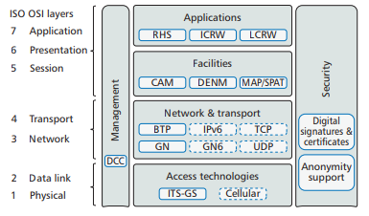

Fig 2.1: Reference model for 1G-V2X

On top of GeoNetworking, the Basic Transport Protocol, BTP provides a UDP-like connectionless transport protocol service. Facilities layer standards specify application-supporting functionality: the cooperative awareness message (CAM) standard conveys critical vehicle state information in support of safety and traffic efficiency applications, with which receiving vehicles can track other vehicles’ positions and movements[8]. While the CAM is a periodic message sent over a single wireless hop, the decentralized environmental notification message (DENM) standard specifies a protocol for dissemination of event-driven safety information in a geographical region, typically via multiple wireless hops. Facility-layer messages for vehicle-to-infrastructure communication are specified in TS 103 301, including for transmission of static information about intersection topologies (MAP) and dynamic information for traffic lights. The standards at the application layer specify requirements for road hazard signaling (RHS), intersection collision risk warning (ICRW), and longitudinal collision risk warning (LCRW). RHS comprises use cases for initial deployment, including emergency vehicle approaching, hazardous location warning, and emergency electronic brake lights. ICRW and LCRW address potential vehicle collisions at intersections and rear-end/head-on collisions. Standards at the security block enable cryptographic protection by digital signatures and certificate; changing pseudonyms for support of anonymity impedes tracking. Finally, management standards mainly cover support for decentralized data congestion control.

**2.4 COMMUNICATION BASED INTERSECTION SAFETY IN EUROPE**

In Europe, specific issues related to communication-based intersection safety were first addressed in the pioneering project INTERSAFE which combined sensor and communication technologies to increase intersection safety. INTERSAFE’s goal was to develop an Intersection Assistant that can reduce or even eliminate fatal accidents at intersections. An Intersection Assistant can provide intersection safety in two main ways. First, the Intersection Assistant can help a vehicle detect others in its neighborhood by means of sensors and bidirectional wireless communication based on the IEEE 802.11p standard. When a potential collision is detected, a driver can be warned to stop for traffic from other directions. Second, a traffic light controller can also be equipped with sensors and communication devices. bidirectional wireless communication and informs them about the traffic light’s status, road conditions and potential hazards detected by sensors installed at an intersection.

**2.5 COMMUNICATION BASED INTERSECTION SAFETY IN JAPAN**

In Japan, the Driving Safety Support Systems (DSSS) have been investigated by the National Policy Agency and the Universal Traffic Management Society of Japan (UTMS). DSSS strives to prevent accidents by providing drivers with warning about potential danger at intersections. Main target scenarios for DSSS are stop sign violation, red light violation, turning accidents, crossing-path accidents, rear-end collision, and collision with pedestrians. For DSSS, UTMS has been developing vehicle-infrastructure cooperative systems and conducting operational tests in four different test sites: Tochigi, Aichi, Kanagawa, and Hiroshima. The roadside infrastructure of DSSS consists of an infrared beacon and a Dedicated Short Range Communication (DSRC) beacon.

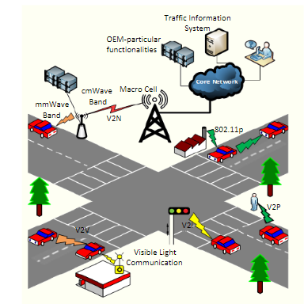

Fig 2.2: Communication Based Intersection Safety

The infrared beacon is placed before an intersection while the DSRC beacon is installed near an intersection. The infrared beacon is periodically broadcast by the roadside infrastructure and realizes two main functions. First, it delivers static information such as road alignment, distance to the intersection, and traffic regulation. Second, it informs approaching vehicles about their specific geographic location and their lane number (infrared beacon is particularly suited for this purpose since its communication range is limited within a few meters and thus provides good accuracy for localization) [9]. The DSRC beacon is broadcast periodically and provides dynamic information at an intersection such as position and speed of pedestrians or other vehicles as detected by roadside sensors. DSRC beacon can provide relevant messages for specific lanes at an intersection. In this case, a vehicle’s onboard unit (OBU) can perform message filtering using the vehicle’s lane number as provided by the infrared beacon. The OBU performs a risk analysis based on information received from the roadside infrastructure. If imminent danger is detected, OBU delivers an acoustic or a visual warning signal. Initial system evaluation for DSSS has been conducted and received positive feedback from test subjects. The evaluation also demonstrated that considerable speed reduction could be achieved for vehicles approaching an intersection. Further cooperative experiments between DSSS and Advanced Safety Vehicle (ASV) are currently being considered for future large-scale ITS operational tests.

**2.6 COMMUNICATION BASED INTERSECTION SAFETY IN THE U.S**

Intersection safety is addressed in the Cooperative Intersection Collision Avoidance Systems Initiative (CICAS) in the U.S. CICAS implements critical safety applications combining different ITS technologies to reduce intersection accidents by providing real-time warnings both in the vehicle and on the infrastructure. The ITS technologies used in CICAS include in-vehicle positioning, roadside sensors, intersection maps, and two-way wireless communication. For wireless communication, CICAS leverages the DSRC technology developed in the Vehicle Infrastructure Integration program (VII).

Four main safety applications are developed in CICAS.

* CICAS-Violation Warning System (CICAS-V)

This application allows the infrastructure to send status information of the traffic light to approaching vehicles using DSRC. Based on this information and in-vehicle GPS, CICAS-V estimates the risk that the vehicle will violate a traffic light. If this risk is sufficiently high, CICAS-V provides a warning to the driver. Two important objects contained in CICAS-V messages are SPAT (signal phase and timing) and GID (geometric intersection description). SPAT informs an approaching vehicle about the traffic light’s status and its remaining time. GID provides geospatial encoding and reference points of an intersection.

* CICAS-Stop Sign Assist (CICAS-SSA)

This application uses sensors installed at an intersection to help drivers in deciding when they can proceed onto or across a high-speed road after stopping at a rural road stop sign. CICASSSA provides drivers with assistance either via animated display sign or wireless communication [10].

* CICAS-Signalized Left-Turn Assist (CICAS-SLTA)

This application uses infrastructure sensors and wireless communication (building from CICAS-V) to assist drivers in making turning maneuvers at an intersection. The application takes oncoming traffic, pedestrians, and other obstacles into consideration.

* CICAS-Traffic Signal Adaptation (CICAS-TSA)

This application combines infrastructure sensors and wireless communication (building from CICAS-V) to detect a dangerous situation when a vehicle violates a red light and can potentially collide with other vehicles. In this case, CICAS-TSA triggers a red light in all directions to protect drivers from an imminent danger. Further, when a vehicle detects a dangerous situation, it can also send a warning message to the infrastructure to trigger an all-red traffic light and prevent a chain reaction of accidents.

**CHAPTER – 3**

**LITERATURE REVIEW**

This chapter describes about the sources of data and literatures investigated which helped for the development of the application and for consideration of problem description. This chapter mainly concentrates on the details of the literature survey done for the project.

**3.1 REVIEW OF LITERATURE**

**i**. **“Real-time vehicle monitoring and positioning using MQTT for reliable wireless connectivity”, Izwan Idris, Faculty of Science and Engineering, Queensland University of Technology 2017.**

Intelligent Transportation System (ITS) advances security estimates where constant data on streets and voyaging vehicles are shared inside a remote correspondence arrange [11]. The ongoing data sharing among vehicles and foundation by means of remote network is otherwise called Cooperative Intelligent Transportation System (C-ITS). One of the key prerequisites in C-ITS or agreeable driving is continuous areas sharing or vehicle localization inside a vehicular correspondence arrange. By observing or following vehicles progressively, ITS can perform high request tasks, for example, situational investigation and versatile thinking to give ace dynamic alerts to the vehicles. This exploration is intended to examine the exhibition of low cost GNSS hardware for exact vehicle situating and investigate the utilization of MQTT for improving gadget availability under an obliged and testing remote cellular network.

Cooperative Intelligent Transportation Systems (C-ITS), to large degree, rely on the ability to provide precise vehicle location and reliable two-way wireless connectivity. For example, by remotely tracking a vehicle’s precise positions in real-time, a central server may provide lane-based safety warning, traffic management and tolling. Lane-level precision is currently achievable using expensive equipment such as survey-grade GNSS receivers and on-board sensors. However, the high hardware, software and operational cost prohibits its use in most domestic road vehicles. On the other hand, C-ITS requires two-way wireless connectivity to maintain communication within its distributed objects such as On-Board-Unit (OBU), Road-Side-Unit (RSU) and central server. The requirements for such communication links varies depending on the C-ITS applications. For instance, road safety related applications require low latency and high reliability communication links, while GNSS correction services accept a much lower-level of communication connectivity performance. Although the wireless connectivity in C-ITS may be enhanced by the Dedicated Short-Range Communication (DSRC) in the near future, the communication connectivity will still depend predominately on cellular networks. As the wireless cellular Internet is known to be vulnerable to various connectivity issues such as service outages, cellular signal blockages and limited data bandwidth, the two-way communication in wireless cellular Internet may experience high latency and even loss of data communication. This research proposes the use of Message Queue Telemetry Transport (MQTT), a machine-to-machine (M2M) based protocol, for establishing a reliable and low-latency two-way communication protocol in wireless connectivity for C-ITS applications. This research aimed to study the performance of low-cost GNSS equipment for precise vehicle positioning and explore the use of MQTT for improving device connectivity under a constrained and challenging wireless cellular network. To facilitate the research studies, a vehicle monitoring platform was implemented which consisted of a vehicle tracking device equipped with a low-cost Ublox single frequency GNSS receiver and Central Monitoring Server (CMS). In addition to the real-time position tracking, a Location Based Service (LBS) application, Surround Traffic Information System (STIS), was developed on the monitoring platform to specifically evaluate MQTT’s Quality of Service (QoS) and publish-subscribe features for an efficient, reliable and responsive two-way communication in wireless connectivity. From a series of kinematic field tests, the low-cost GNSS equipment on-board of a vehicle had achieved 70 % of the high precision solutions with a combination of lane level and where-in-lane-level (decimetre) of accuracy relative to the solutions acquired by survey4 grade equipment. However, the system still faces difficulties in severe multipath and challenging environments, such as tree canopies, overhead bridges, signal blockage, etc. Field tests of wireless connectivity performance have shown that MQTT had significantly outperformed the TCP socket and HTTP based communications in achieving lower average latency for tracking vehicle's positions from the central monitoring server. Although the User Datagram Protocol (UDP) socket based communication had outperformed all other communication protocols including MQTT in the average latency, network data analyses had showed that UDP had suffered data duplication and latencies were heavily affected when there were significant changes in the connectivity such as drops in the cellular signal strength. Furthermore, MQTT with its QoS levels feature has been proven to be able to establish a reliable connectivity by recovering any lost message due to a disruption in wireless cellular connection. Finally, a road experiment with STIS application had proved that MQTT could provide a low-latency and responsive two-way communication between distributed devices. Moving forward, the usage of MQTT protocol can be further extended in the underlying implementation of NTRIP casters to improve latency and ensure data reliability in receiving GNSS data corrections via wireless connectivity.

**ii. “Vehicle Talks to IoT for Better Driving Experience”, Alanazi Yunus Ali S, Alsalem Hussain, Kogakuin University, Tokyo, Japan.**

In this paper, accurate information about the rain level is collected and detected in a sub-module, which is implemented as rain level detection algorithm by reading real-time sensor information from the database, checking for wipers speeds in the vehicle, and then preparing data to make the needed IoV path way. In addition, vehicles should be able to organize themselves in order to avoid traffic congestion and to optimize drive energy usage. Vehicles today are undergoing rapid and strong development, and will rely on themselves to provide data and make decision based on this data. However, this may be done in coordination and cooperation with the infrastructure of a smart city traffic congestion control and management system.

Internet of Things (IoT) has many benefits and features in technology. It creates a major change in the behavior of people's daily lives. IoT is able to save time, money and effort as well. It creates new opportunities for development, innovation, and knowledge. Also, IoT is able to solve challenges smart cities are facing by providing and collecting information. When IoT technology intervenes in the field of vehicles, it creates a new concept. The concept of Internet of Vehicles (IoV) is a future for smart transport. Smart sensors in vehicles are used to collect information from cloud server by using protocols such as CoAP and MQTT. This requires robust sensors which are able to deliver reliable information to the systems, such as vehicle status, position, energy usage profile, and driving profile. They interact with external systems (traffic control systems, parking management, electric vehicle charging). The idea is that an IoT can be assigned an IP address and provided with the ability to transfer data to a network. Vehicle fuel sensor is capable of alerting the driver when the tank is empty and shows the energy status of the vehicle. The IoT protocols will allow monitoring and controlling remotely over an existing network, resulting in improvement based on accuracy, efficiency, and security. In the past years, the new advantages implemented by the vehicle (automobile) manufacturers, became increasingly software driven and dependant at the same time. The auto industry has a longer and richer track record than any other sector by offering a series of improvements aimed at safer driving or self-driving in order to avoid a collision. However, this can be done by studying how IoV can eliminate the needs to be in the close connection with a vehicle to perform diagnostics. Through surveillance, all the aspects of the vehicles are easier to reveal any trouble in advance by sending all sensor readings to a certified centre where the service of the vehicles company will be able to find and predict check failures of key systems integrated into the vehicle. In addition to the check part, this management system will help drivers to keep track of the yearly maintenance, programming service appointments or in analysing the fuel consumption as well as giving advice for a friendlier driving style. In a difficult (extreme) situation such as in the case of an accident, a system would be able to inform the emergency rescue service when the driver is helpless, finding the chances for the wounded to live by reducing the overall time of the rescue mission.

# iii. “Cellular V2X Transmission for Connected and Autonomous Vehicles: Standardization, Applications, and Enabling Technologies in[IEEE Consumer Electronics Magazine](https://www.researchgate.net/journal/2162-2256_IEEE_Consumer_Electronics_Magazine) · May 2019”

A plethora of technologies is being developed for 5G to support C-V2Xand other applications. This includes edge computing, network slicing, virtualization, and advanced antenna systems - thereby providing a rich architecture for vehicular communications. For instance, the mm Wave bands introduced in 5G will also be particularly suited for V2N high volume data transfer due to their dramatically higher spectrum size. In addition, Multi-access Edge Computing (MEC) is being standardized by the European Telecommunications Standards Institute (ETSI) to create an open multi-vendor cloud environment at the edge of the Radio Access Network (RAN), which is useful for efﬁcient V2X content delivery. MEC will off- load data-intensive tasks for edge processing, thereby reducing trafﬁc bottlenecks in the core of mobile network, which translates to reduced end-to-end network latency and facilitates near real-time network analytics

Today, more than 30,000 Americans die in car accidents annually, mostly due to human error. Autonomous Vehicles (AVs) are anticipated to reduce trafﬁc accidents and their associated deaths by about 90% . For instance, automatic emergency braking has been forecasted to reduce insurance claims by up to 38% . Equally important is the fuel efﬁciency that intelligent driving will provide. Studies have shown that more than 15% reduction in fuel consumption can be achieved from efﬁcient congestion management of AVs. At the heart of this mobility transformation, are the phenomenal advances in vehicle sensor, computing, and storage technologies that are facilitating the development of Advanced Driver- Assistance Systems (ADAS) [12]. The value of future cars is therefore shifting from the chassis and powertrain to electronics and sensor capabilities (∼35% of car costs in 2025). Approximately 90% of all innovations in new cars are now driven by electronics.

Along with these exciting AV developments, Cellular Vehicle-to-Everything (C-V2X) communication is emerging as an important enabler for connected and autonomous transportation. For instance, by allowing vehicles to communicate with each other, AV navigation will be more reliable and efﬁcient since vehicles will exchange driving intent (lane changes, braking, etc.) offering situation awareness beyond the capabilities of AV sensors. Vehicular data will therefore gradually dominate network trafﬁc, requiring novel network architectures to support this growth. The focus of this article is to present an overview of the C-V2X developments, discuss the enabling technologies for V2X, the role of network intelligence for scalable deployments, and the efﬁcient delivery of videos for different V2X applications.

Today, more than 30,000 Americans die in car accidents annually, mostly due to human error. Autonomous Vehicles (AVs) are anticipated to reduce trafﬁc accidents and their associated deaths by about 90% . For in-stance, automatic emergency braking has been forecasted to reduce insurance claims by up to 38% . Equally important is the fuel efﬁciency that intelligent driving will provide. Studies have shown that more than 15%reduction in fuel consumption can be achieved from efﬁcient congestion management of AVs. At the heart of this mobility transformation, are the phenomenal advances in vehicle sensor, computing, and storage technologies that are facilitating the development of Advanced Driver-Assistance Systems (ADAS) . The value of future cars is therefore shifting from the chassis and power train to electronics and sensor capabilities (∼35% of car costs in 2025). Approximately 90% of all innovations in new cars are now driven by electronics. Along with these exciting AV developments, Cellular Vehicle-to-Everything (C-V2X) communication is emerging as an important enabler for connected and autonomous transportation. For instance, by allowing vehicles to communicate with each other, AV navigation will be more reliable and efﬁcient since vehicles will exchange driving intent (lane changes, braking, etc.) offering situation awareness beyond the capabilities of AV sensors. Vehicular data will therefore gradually dominate network trafﬁc, requiring novel network architectures to support this growth. The focus of this article is to present an overview of the C-V2X developments, discuss the enabling technologies for V2X, the role of network intelligence for scalable deployments, and the efﬁcient delivery of videos for different V2X applications.

**iv. “Impact of VANET-based V2X communication using IEEE 802.11p on reducing vehicles traveling time in realistic large scale urban area Conference: 2013 International Conference on Connected Vehicles and Expo (ICCVE)”**

To solve traffic related problems, one of the useful solutions is wireless communication technology which focuses on the third strategy. Vehicle to Vehicle (V2V) or Car to Car

Communication (C2CC) and Vehicle to Infrastructure (I2V or V2I) communication based on wireless technology is developed in order to make vehicles capable to “communicate” to Road Side Units (RSU) and each other. V2V and V2I have several applications in Intelligent Transportation Systems (ITSs) to make transportation more efficient. This paper focuses on the real-time monitoring of the traffic of the streets and calculates the best route for the drivers using the on-line traffic status of the roads. This efficient method for selection of the routes decreases traveling time for each journey which can decrease the traffic congestion and save the resources [13]. Calculating the best route, requires two types of data, first the current traffic information of the cities and roads are required, then, by using this information, calculation of the routes becomes possible.

Vehicle to Vehicle (V2V) or Car to Car Communication (C2CC) and Vehicle to Infrastructure (I2V or V2I) communication based on wireless technology is developed in order to make vehicles capable to communicate to Road Side Units (RSU) and each other. This paper centres on the continuous checking of the traffic of the avenues and computes the best course for the drivers utilizing the on-line traffic status of the streets. This proficient technique for choice of the courses diminishes travelling time for each journey which can diminish the traffic blockage and spare the resources. Computing the best course, requires two kinds of information, first the present traffic data of the urban communities and streets are required, at that point, by utilizing this data, estimation of the courses winds up conceivable.

Vehicle to Vehicle (V2V) or Car to Car and Vehicle to Infrastructure (I2V or V2I) communication are important components of the Intelligent Transportation Systems (ITS) architecture. One of the promising applications of ITS is calculating the estimated traveling time dynamically and showing drivers the fastest vehicular route to the destination, which has several benefits such as decreasing emissions, traffic congestion, fuel consumption, etc. This paper proposes a new method to find the fastest route from origin to destination by using the V2X (V2V or V2I) communication which provides real-time traffic information to drivers. This method, assigns a Current Traveling Time (CTT) for each street in a city which could help drivers to find the best route and also it could help real-time monitoring of the traffic of the streets. The contribution of this study is threefold: First, the mentioned novel methods are proposed. Second, impact of the method is investigated by using SUMO as a traffic simulator and also dynamic route planning with employing CTT for each street which are calculated with the proposed method [14]. Third, mentioned scenario is simulated by using OMNET++ as a VANET (with IEEE 802.11p standard) with employing Veins framework. Veins framework is able to run OMNET++ and SUMO in parallel. Veins is developed in this paper by adding new modules to OMNET++ which aims to add numerous Roadside Units (RSUs) in the realistic traffic simulation. Moreover, to control the traffic simulation, in this paper a new program written in Python capable to connect to SUMO has been developed. This program connects to SUMO and by considering every single vehicle movement simulate a microscopic traffic, also calculating the Current Traveling Time for streets and dynamic route planning for the cars. This program dynamically calculates the fastest route for the specific car.

# v. “Enhancements of V2X communication in support of cooperative autonomous driving”

[**Laurens Hobert**](https://ieeexplore.ieee.org/author/37085428056)**,**[**Andreas Festag**](https://ieeexplore.ieee.org/author/37085410374)**,**[**Ignacio Llatser**](https://ieeexplore.ieee.org/author/37704099800)**,**[**Luciano Altomare**](https://ieeexplore.ieee.org/author/37085725044)**, [Filippo Visintainer](https://ieeexplore.ieee.org/author/38072354700), [Andras Kovacs](https://ieeexplore.ieee.org/author/37662711200),**[**IEEE Communications Magazine**](https://ieeexplore.ieee.org/xpl/RecentIssue.jsp?punumber=35)**( Volume: 53 ,**[**Issue: 12**](https://ieeexplore.ieee.org/xpl/tocresult.jsp?isnumber=7355551)**, Dec. 2015 )**

Two emerging technologies in the automotive domain are autonomous vehicles and V2X communication. Even though these technologies are usually considered separately, their combination enables two key cooperative features: sensing and maneuvering. Cooperative sensing allows vehicles to exchange information gathered from local sensors. Cooperative maneuvering permits inter-vehicle coordination of maneuvers. These features enable the creation of cooperative autonomous vehicles, which may greatly improve traffic safety, efficiency, and driver comfort. The first generation V2X communication systems with the corresponding standards, such as Release 1 from ETSI, have been designed mainly for driver warning applications in the context of road safety and traffic efficiency, and do not target use cases for autonomous driving. This article presents the design of core functionalities for cooperative autonomous driving and addresses the required evolution of communication standards in order to support a selected number of autonomous driving use cases. The article describes the targeted use cases, identifies their communication requirements, and analyzes the current V2X communication standards from ETSI for missing features. The result is a set of specifications for the amendment and extension of the standards in support of cooperative autonomous driving.

# vi. “Realistic Simulation of V2X Communication Scenarios”, Tobias Queck, Bjorn Schunemann , Ilja Radusch, Prof. Christoph Meinel, [2008 IEEE Asia-Pacific Services Computing Conference](https://ieeexplore.ieee.org/xpl/mostRecentIssue.jsp?punumber=4780614), 9-12 Dec. 2008

Vehicle-2-X (V2X) Communication provides the foundation for new applications that enhance both safety and traffic efficiency. Before V2X applications can be deployed in practice, their in-depth analysis is necessary. For this end, detailed and realistic simulations are essential. Depending on the simulated V2X Communication application, particular simulators have to be coupled. For this purpose, we have developed the V2X Simulation Runtime Infrastructure (VSimRTI) offering the flexibility to combine arbitrary simulators. The VSimRTI is derived from concepts of the High Level Architecture (HLA). It synchronizes the simulators and enables the communication among them. Another feature of our simulation environment is the emulation of the environment of V2X Communication applications in real vehicles. As a result, we can integrate real V2X Communication applications without modifications [15]. The vehicle management is responsible for the storage and synchronization of vehicle data relevant in several federates. We decided to store this data inside the VSimRTI because it is used in most of the V2X related simulators. To avoid inconsistent data, only one federate is allowed write access at a time. Any federate is allowed to read data when no federate has approved write access. If there are concurrent read or write access claims, the federates are scheduled in a first-come-firstserved manner.

**vii. “Fuzzy Traffic Control with Vehicle-to-Everything Communication”,** [**Muntaser A. Salman**](https://www.mdpi.com/search?authors=Muntaser%20A.%20Salman&orcid=0000-0002-8347-2729)**, Suat Ozdemir,** [**Fatih V. Celebi**](https://www.mdpi.com/search?authors=Fatih%20V.%20Celebi&orcid=)**, Department of Information Systems, College of Computer Sciences and Information Technology, University of Anbar, 55431 Baghdad, 55 Ramadi, Anbar, Iraq, 27 January 2018**

Traffic signal control (TSC) with vehicle-to everything (V2X) communication can be a very efficient solution to traffic congestion problem. Ratio of vehicles equipped with V2X communication capability in the traffic to the total number of vehicles (called penetration rate PR) is still low, thus V2X based TSC systems need to be supported by some other mechanisms. PR is the major factor that affects the quality of TSC process along with the evaluation interval. Quality of the TSC in each direction is a function of overall TSC quality of an intersection. Hence, quality evaluation of each direction should follow the evaluation of the overall intersection. Computational intelligence, more specifically swarm algorithm, has been recently used in this field in a European Framework Program FP7 supported project called COLOMBO. In this paper, using COLOMBO framework, further investigations have been done and two new methodologies using simple and fuzzy logic have been proposed. To evaluate the performance of our proposed methods, a comparison with COLOMBOs approach has been realized. The results reveal that TSC problem can be solved as a logical problem rather than an optimization problem. Performance of the proposed approaches is good enough to be suggested for future work under realistic scenarios even under low PR.

**viii. “Object identification for computer vision using image segmentation”,** [**Debalina Barik**](https://ieeexplore.ieee.org/author/37547267700)**; [Manik Mondal](https://ieeexplore.ieee.org/author/37544154700),**[**2010 2nd International Conference on Education Technology and Computer**](https://ieeexplore.ieee.org/xpl/mostRecentIssue.jsp?punumber=5508190)**, 22-24 June 2010**

Object detection for computer vision is one of the key factors for scene understanding. It is still a challenge today to accurately determine an object from a background where similar shaped objects are present in a large number. In this paper we proposed a method for object detection from such chaotic background by using image segmentation and graph partitioning. We build a “feature set” from the original object and then we train the system using the “feature set” and graph partitioning on the chaotic image. Testing is done on computer manipulated images and real world images. In both the cases our system identified the search object among other similar objects successfully. Image Segmentation for object detection is the most vital part of computer vision where the computer has to identify objects differently from the background whether it is a face or hand or a man or simply static objects.If the contrast difference of the background with the foreground is high then the detection is simple. But if the background is chaotic and there is a little difference between the background and the object then it becomes difficult for the system to identify the edges from the background. The major issues in object detection are the shape variance, lighting variance and objects' pose variances.

# ix. “Demo: Vehicle-to-everything middleware supporting multiple access technologies for improving network coverage”, Hitoshi Hayakawa, [2017 IEEE Vehicular Networking Conference (VNC)](https://ieeexplore.ieee.org/xpl/mostRecentIssue.jsp?punumber=8267164)27-29 Nov. 2017

Multiple access technologies such as IEEE 802.11p (11p) and long term evolution vehicle-to-everything (LTE-V2X) are expected to be used for vehicle-to-everything (V2X) communication. To improve the network coverage, terminals using different access technologies should be involved in the same V2X communication. To achieve this, we extended middleware designed for 11p to support multiple access technologies. In the middleware, access to hardware employing the 11p or other access technologies is abstracted, and bridging function among the abstracted hardware is implemented while keeping the same interface to the upper layers. Using the middleware, V2X communication among terminals employing different access technologies has been successfully demonstrated.

**x. “A comparison of cellular vehicle-to-everything and dedicated short range communication”,** [**Tien Viet Nguyen**](https://ieeexplore.ieee.org/author/37086320543)**,** [**Patil Shailesh**](https://ieeexplore.ieee.org/author/37086322527)**,** [**Baghel Sudhir**](https://ieeexplore.ieee.org/author/37086321504)**,** [**Gulati Kapil**](https://ieeexplore.ieee.org/author/37086324054)**,** [**Libin Jiang**](https://ieeexplore.ieee.org/author/37086325013)**,** [**Zhibin Wu**](https://ieeexplore.ieee.org/author/37085749327)**,** [**Durga Malladi**](https://ieeexplore.ieee.org/author/37296823900)**,** [**Junyi Li**](https://ieeexplore.ieee.org/author/37715748500)**,**[**2017 IEEE Vehicular Networking Conference (VNC)**](https://ieeexplore.ieee.org/xpl/mostRecentIssue.jsp?punumber=8267164) **27-29 Nov. 2017**

Vehicle to Everything (V2X) communication, which involves vehicles disseminating information about its type, location and movement are known to help increasing road safety. At physical layer, there are two main solutions: 1) Dedicated Short Range Communication, which is based on IEEE 802.11p standard and 2) Cellular V2X, which is a recent development in 3GPP LTE standard to support V2X use case. In this paper, we provide our comparison of the performance of the two aforementioned technologies at both link level and system level. Based on this study, one can see that Cellular V2X provides significant improvement over Dedicated Short Range Communication in terms of communication range, without suffering in other aspects. This improvement is equivalent to longer reaction time and more lives saved in the road.

**CHAPTER 4**

**PROBLEM DEFINITION**

**4.1 PROBLEM STATEMENT**

More than 1.3 million people die on the roads every year. 90 percent of fatal car accidents are caused by human error. There were 5.6 million police-reported motor vehicle crashes in 2015, and the number of fatalities from police-reported motor vehicle crashes continues to rise. To overcome these problems, connected vehicle technologies will provide drivers with the tools they need to anticipate potential crashes and significantly reduce the number of lives lost each year. This identified problem for this project can be stated as **“Vehicle to Everything (V2X) communication system”** which will improve driving comfort and has the potential to save lives by preventing many traffic accidents.

**4.2 PROBLEM OBJECTIVES**

The problem objectives are listed below:

* To review literature on existing V2X techniques, vision based techniques, its latest trends, its recent developments and Communication protocols.
* To analyse the requirements for Vehicle to Everything (V2X) communication system and arrive at the design specifications based on the reviewed literature.
* To arrive at functional block diagram for V2X system using the identified design specifications based on the analysed requirements
* To develop the individual blocks of the arrived functional block diagram for V2X system..
* To implement the V2X system by integrating the individual developed blocks with relevant interfaces.
* To test the implemented prototype of V2X system using appropriate test cases for its working functionality.

**4.3 METHODOLOGY**

The following algorithm represents the methodology used in this project:

* Literature review on V2X techniques, vision based techniques and Communication protocols will be carried out by referring books, journals, technical papers and related documents.
* High level requirements for Vehicle to Everything (V2X) communication system will be identified based on the literature review.
* High level design specifications for V2X system will be developed based on literature review.
* Functional block diagram of V2X system will be arrived using design specifications.
* High level design specifications of V2X system will be translated to low level design by dividing into sub blocks and the interfaces between the sub blocks will be identified.
* Hardware specifications will be derived for the identified sub-blocks.
* The microcontroller will be chosen for developing different V2X functionalities based on literature review.
* The Nodemcu microcontroller will be interfaced to the GPS module for acquiring parameters such as position coordinates, speed and direction of heading.
* The Vehicle to Vehicle (V2V) system, Vehicle to Infrastructure (V2I) system will be developed using Arduino IDE.
* Vehicle to Pedestrian (V2P) functionality is implemented by using Raspberry pi microcontroller.
* The V2P system on Raspberry pi will be integrated with cameras and vision techniques for detecting pedestrians.
* A webpage will be created for plotting the V2X elements on map.
* Haversine formula is used to compute distance between two GPS coordinates. Haversine formula is given below.

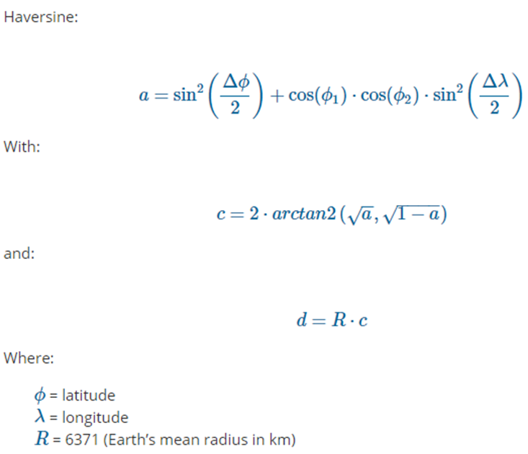

* The test cases for verifying the V2X system will be developed using the literature review.
* The test cases will be developed to test the individual integration of the chosen hardware components.
* The tested hardware components will be integrated according to the arrived functional block diagram.
* Required microcontroller drivers and software will be developed for the corresponding hardware using the appropriate cross development Environment.
* The developed software will be integrated with the hardware and the designed integration test cases will be executed for its Functionality.

**CHAPTER 5**

### DESIGN AND DEVELOPMENT OF V2X COMMUNICATION

This chapter gives the overview of the development of V2X Communication. The overview of system block diagram and the operation of high level diagram of V2X Communication are discussed in this chapter. The various hardware and software requirements for implementing V2X is discussed in this chapter.

**5.1 SYSTEM DESIGN REQUIREMENTS**

Raspberry pi is used as a server where MQTT broker and Blynk local server runs and is also used to monitor the number of vehicles and infrastructures such as traffic lights and road signs present in an area. Nodemcu is installed in each vehicle to publish its current location and other parameters to nearby vehicles. ESP8266 modules are installed on traffic lights and road signs to publish its information to all the vehicles near to it. GPS modules are used to acquire location coordinates (latitude, longitude), speed and direction of each vehicle. Ultrasonic sensors are used to warn any obstacles ahead of a vehicle. LCD modules are used to display the received information in a vehicle. Arduino Uno is used to program ESP8266 modules.

**5.2 SYSTEM DESIGN OF V2X COMMUNICATION**

Vehicle to Vehicle (V2V) is implemented using NodeMCU which is a microcontroller placed in each vehicle. GPS module is used to acquire position coordinates, speed and direction of the vehicle. Vehicle to Infrastructure(V2I) is implemented using NodeMCU or esp8266 modules as controllers in infrastructure elements such as traffic lights or caution signs to broadcast their respective information. The acquired parameters are then broadcast to the vehicles nearby using MQTT protocol.

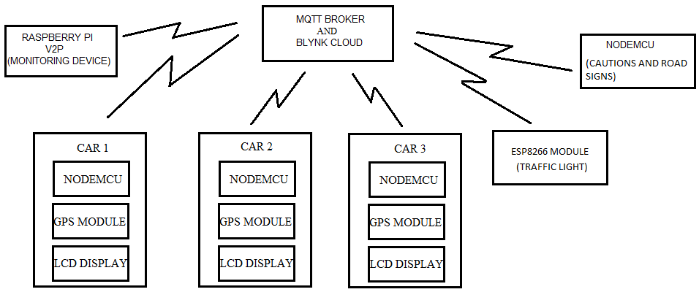

Fig. 5.1: Block diagram of V2X architecture

The MQTT broker used can either be a local server or online cloud based servers. If a local server is used, then all the vehicles in the grid and the server are to be connected to the same network. For this, Wi-Fi access points need to be installed after every 100m depending on the range of the router. If online cloud based servers are used, then the devices installed on each vehicle or infrastructure components can be connected to their respective networks, in which case internet is essential. This benefits the user to cover larger area. The controllers used in vehicles are programmed in such a way that the nearby vehicles and infrastructure elements within the specified range are only visible.

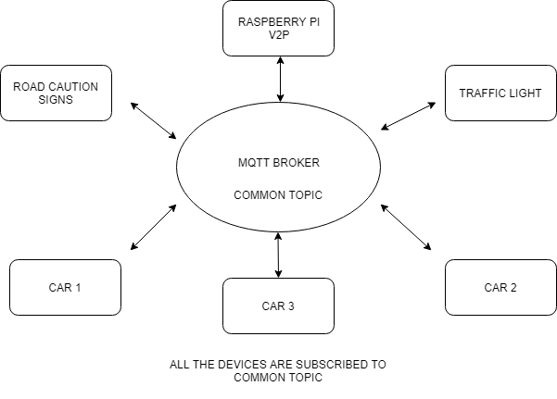

Fig 5.2: MQTT model

All V2X elements are subscribed to a common topic such that the elements can publish their respective information as well as receive information from other V2X elements. **The MQTT broker is responsible for receiving all messages, filtering the messages, determining who is subscribed to each message, and sending the message to these subscribed clients.**

Raspberry pi is used to monitor the data flow between vehicles and infrastructure components. All the published data from different V2X elements will be stored on a log file using Raspberry pi such that necessary computations can be applied on data for analysing different road network conditions. Raspberry pi is also used to implement vehicle to pedestrian (V2P) functionality which uses Video processing to detect pedestrians crossing the road and warns vehicles about their presence on the road.

The data received from the subscribed topic is then displayed on the webpage where the received coordinates are plotted on map. Information regarding vehicles and infrastructure elements will also be displayed in the form of tables on webpage. Application built using Blynk platform is also used to view the nearby vehicles and infrastructure elements on map widget and also necessary infrastructure details will be displayed. LCD module installed on each vehicle is used to display infrastructure elements details or any priority information regarding road network.

**5.3 CIRCUIT DESCRIPTION**

The figure 5.3 represents the circuit description of V2V communication of a single vehicle. NodeMCU is the main controller of the car. The data obtained from gps module such as latitude, longitude, time, date, speed and bearing are sent to NodeMCU. The data received from other vehicles or infrastructure elements along with gps data are processed by the NodeMCU. The required information in serial form is converted to parallel form by I2C module for displaying the data on to the LCD display.

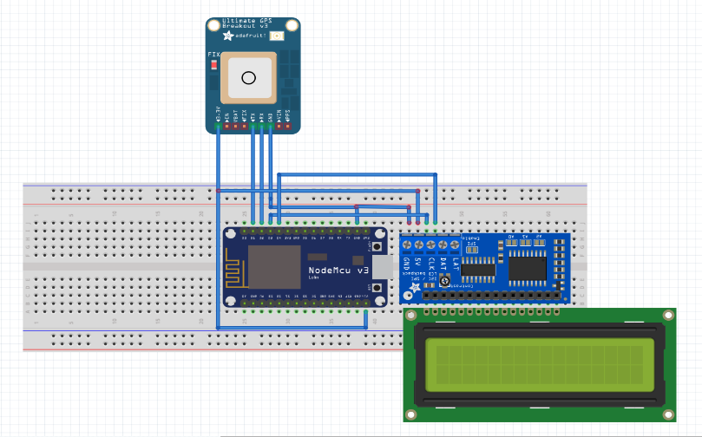

Fig 5.3: Circuit diagram of V2V communication

V2I architecture consists of either a ESP8266 module or a NODEMCU in each of the infrastructure elements such as traffic lights, caution signs and parking space availability systems. The data comprises of the location of a particular infrastructure element and the information to be relayed to nearby vehicles.

V2P architecture consists of raspberry pi controller and cameras installed at intersections and pedestrian crossings. Image processing is used to detect the presence of pedestrians at these intersections/pedestrian crossings to warn nearby vehicles regarding their presence.

**5.4 HARDWARE DESCRIPTION**

* NEO-6M GPS module
* ESP8266 NODEMCU
* LCD module
* I2C module
* Raspberry pi 3 B+

**5.4.1 ESP8266 NODEMCU**

The [NodeMCU](http://nodemcu.com/index_en.html" \t "_blank) (Node Microcontroller Unit) is open source software and hardware development environment that is built around a very inexpensive System-on-a-Chip (SoC) called the ESP8266. It includes firmware which runs on the ESP8266 Wi Fi [SoC](https://en.wikipedia.org/wiki/System_on_a_chip" \o "System on a chip) from [Espressif Systems](https://en.wikipedia.org/w/index.php?title=Espressif_Systems&action=edit&redlink=1" \o "Espressif Systems (page does not exist)), and hardware which is based on the ESP-12 module. The term "NodeMCU" by default refers to the firmware rather than the development kits. The firmware uses the [Lua](https://en.wikipedia.org/wiki/Lua_(programming_language)" \o "Lua (programming language))scripting language. It is based on the eLua project, and built on the Espressif Non-OS SDK for ESP8266. It uses many open source projects, such as lua-cjson, and spiffs [16].

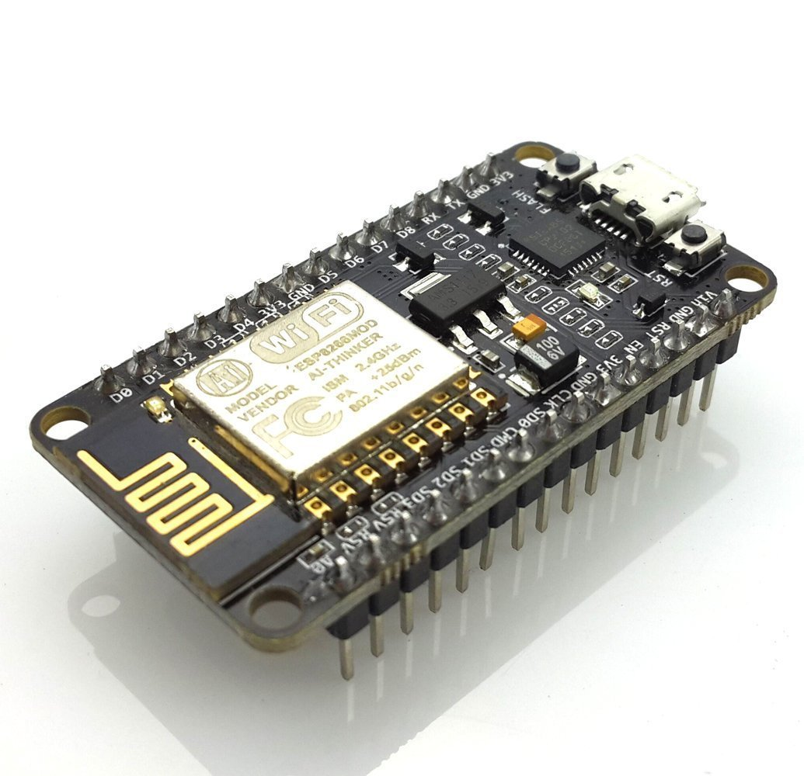

Fig 5.4: ESP8266 Node-MCU

It has two key components.

1. An open source ESP8266 [firmware](https://github.com/nodemcu/nodemcu-firmware) that is built on top of the chip manufacturer's proprietary SDK. The firmware provides a simple programming environment based on [eLua](http://www.eluaproject.net/" \t "_blank) (embedded [Lua](https://www.lua.org/" \t "_blank)), which is a very simple and fast scripting language with an established developer community. For new comers, the Lua scripting language is easy to learn.
2. A [DEVKIT board](https://github.com/nodemcu/nodemcu-devkit) that incorporates the ESP8266 chip on a standard circuit board. The board has a built-in USB port that is already wired up with the chip, a hardware reset button, wifi antenna, LED lights, and standard-sized GPIO (General Purpose Input Output) pins that can plug into a bread board.

**5.4.2 ESP8266 BLOCK DIAGRAM AND FEATURES**



Fig 5.5: ESP8266 block diagram

Features:

• 802.11 b/g/n

• Integrated low power 32-bit MCU

• Integrated 10-bit ADC

• Integrated TCP/IP protocol stack

• Integrated TR switch, balun, LNA, power amplifier and matching network

• Integrated PLL, regulators, and power management units

• Supports antenna diversity

• WiFi 2.4 GHz, support WPA/WPA2

• Support STA/AP/STA+AP operation modes

• Support Smart Link Function for both Android and iOS devices

• SDIO 2.0, (H) SPI, UART, I2C, I2S, IR Remote Control, PWM, GPIO

• STBC, 1x1 MIMO, 2x1 MIMO

• A-MPDU & A-MSDU aggregation & 0.4s guard interval

• Deep sleep power <10uA, Power down leakage current < 5uA

• Wake up and transmit packets in < 2ms

• Standby power consumption of < 1.0mW (DTIM3)

• +20 dBm output power in 802.11b mode

• Operating temperature range -40C ~ 125C

• FCC, CE, TELEC, WiFi Alliance, and SRRC certified

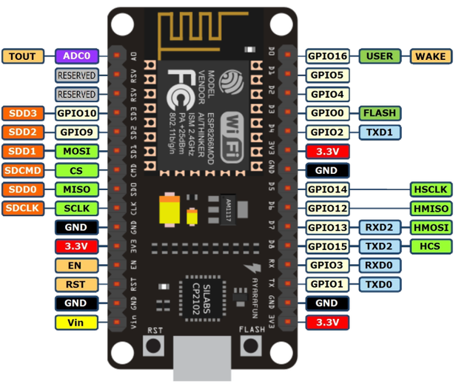

Fig 5.6: ESP8266 pin diagram

**5.4.3 Raspberry pi 3 B+**

* The Raspberry Pi 3 Model B+ is the latest product in the Raspberry Pi 3 range,boasting a 64-bit quad core processor running at 1.4GHz, dual-band 2.4GHz and 5GHz wireless LAN, Bluetooth 4.2/BLE, faster Ethernet, and PoE capability via a separate PoE HAT.
* The dual-band wireless LAN comes with modular compliance certification, allowing the board to be designed into end products with significantly reduced, wireless LAN compliance testing,improving both cost and time to market [17].
* The Raspberry Pi 3 Model B+ maintains the same mechanical footprint as both the Raspberry Pi 2 Model B and the Raspberry Pi 3 Model B.

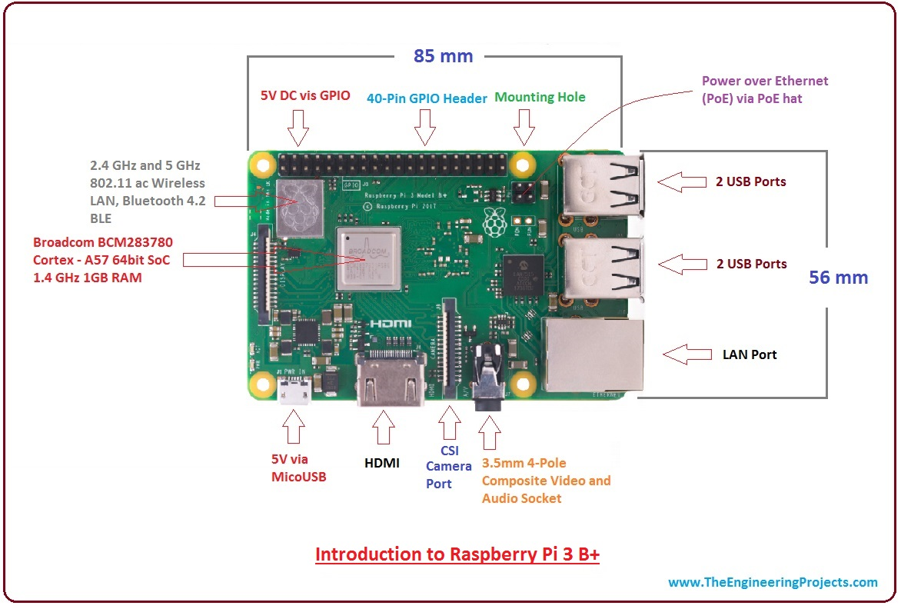

Fig 5.7: Raspberry Pi 3 B+

Features:

* SoC: Broadcom BCM2837B0 quad-core A53 (ARMv8) 64-bit @ 1.4GHz
* GPU: Broadcom Videocore-IV
* RAM: 1GB LPDDR2 SDRAM
* Networking: Gigabit Ethernet (via USB channel), 2.4GHz and 5GHz 802.11b/g/n/ac Wi-Fi
* Bluetooth: Bluetooth 4.2, Bluetooth Low Energy (BLE)
* Storage: Micro-SD
* GPIO: 40-pin GPIO header, populated
* Ports: HDMI, 3.5mm analogue audio-video jack, 4x USB 2.0, Ethernet, Camera Serial Interface (CSI), Display Serial Interface (DSI)
* Dimensions: 82mm x 56mm x 19.5mm, 50g
* Broadcom BCM2837B0, Cortex-A53 (ARMv8) 64-bit SoC @ 1.4GHz
* - 1GB LPDDR2 SDRAM
* - 2.4GHz and 5GHz IEEE 802.11.b/g/n/ac wireless LAN, Bluetooth 4.2, BLE
* - Gigabit Ethernet over USB 2.0 (maximum throughput 300 Mbps)
* - Extended 40-pin GPIO header
* - Full-size HDMI
* - 4 USB 2.0 ports
* - CSI camera port for connecting a Raspberry Pi camera
* - DSI display port for connecting a Raspberry Pi touchscreen display
* - 4-pole stereo output and composite video port
* - Micro SD port for loading your operating system and storing data
* - 5V/2.5A DC power input
* - Power-over-Ethernet (PoE) support (requires separate PoE HAT)

**5.4.4 NEO-6M GPS module**

The NEO-6M GPS module is a well-performing complete GPS receiver with a built-in 25 x 25 x 4mm ceramic antenna, which provides a strong satellite search capability. With the power and signal indicators, you can monitor the status of the module. Thanks to the data backup battery, the module can save the data when the main power is shut down accidentally. Its 3mm mounting holes can ensure easy assembly on your aircraft, which thus can fly steadily at a fixed position, return to Home automatically, and automatic waypoint flying, etc [18].

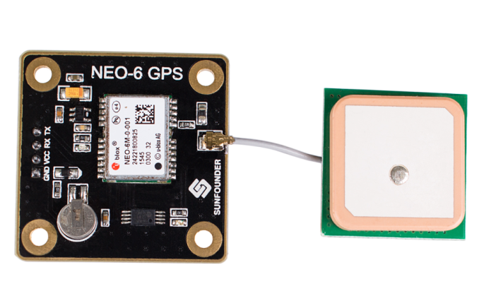

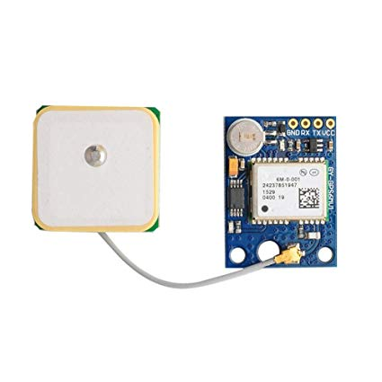

Fig 5.8: NEO-6M GPS module

Features:

* A complete GPS module with an active antenna integrated, and a built-in EEPROM to save configuration parameter data.
* Built-in 25 x 25 x 4mm ceramic active antenna provides strong satellite search capability.
* Equipped with power and signal indicator lights and data backup battery.
* Power supply: 3-5V; Default baud rate: 9600bps.
* Interface: RS232 TTL
* Receiver type: 50 channels
* GPS L1(1575.42Mhz) C/A code
* SBAS:WAAS/EGNOS/MSAS
* Horizontal position accuracy: 2.5mCEP (SBAS:2.0mCEP)
* Navigation update rate: 5Hz maximum (1HZ default)
* Capture time: Cool start: 27s (fastest)
* Hot start: 1s Tracking & Navigation
* sensitivity: -161dBm
* Communication protocol: NMEA(default)/UBX
* Binary Serial baud rate: 4800, 9600(default), 19200, 38400, 57600, 115200, 230400
* Operating temperature: -40℃ ~ 85℃
* Operating voltage: 2.7V~5.0V(power supply input via VCC)
* Operating current: 45mA TXD/RXD impedance: 510Ohms

**5.4.5 I2C module**

I2C module is a [synchronous](https://en.wikipedia.org/wiki/Synchronous_circuit), [multi-master, multi-slave](https://en.wikipedia.org/wiki/Master/slave_(technology)), [packet switched](https://en.wikipedia.org/wiki/Packet_switching), [single-ended](https://en.wikipedia.org/wiki/Single-ended_signaling), [serial](https://en.wikipedia.org/wiki/Serial_communication) [computer bus](https://en.wikipedia.org/wiki/Bus_(computing)) invented in 1982 by [Philips Semiconductor](https://en.wikipedia.org/wiki/Philips) (now [NXP Semiconductors](https://en.wikipedia.org/wiki/NXP_Semiconductors)). It is widely used for attaching lower-speed peripheral [ICs](https://en.wikipedia.org/wiki/Integrated_circuit) to processors and [microcontrollers](https://en.wikipedia.org/wiki/Microcontroller) in short-distance, intra-board communication.

It allows multiple "slave" digital integrated circuits ("chips") to communicate with one or more "master" chips. Like the Serial Peripheral Interface (SPI), it is only intended for short distance communications within a single device. Like Asynchronous Serial Interfaces (such as RS-232 or UARTs), it only requires two signal wires to exchange information

The I2C-bus is a de facto world standard that is now implemented in over 1000 different ICs manufactured by more than 50 companies. Additionally, the versatile I2C-bus is used in various control architectures such as System Management Bus (SMBus), Power Management Bus (PMBus), Intelligent Platform Management Interface (IPMI), Display Data Channel (DDC) and Advanced Telecom Computing Architecture (ATCA). This document assists device and system designers to understand how the I2C-bus works and implement a working application. Various operating modes are described. It contains a comprehensive introduction to the I2C-bus data transfer, handshaking and bus arbitration schemes. Detailed sections cover the timing and electrical specifications for the I2C-bus in each of its operating modes. Designers of I2C-compatible chips should use this document as a reference and ensure that new devices meet all limits specified in this document. Designers of systems that include I2C devices should review this document and also refer to individual component data sheets

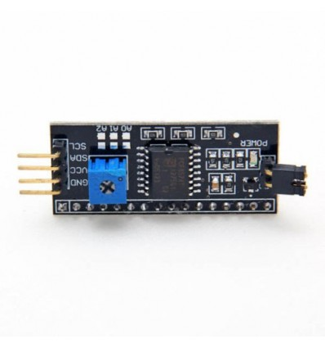

Fig 5.9: I2C module

Features:

* Master transmission and receipt
* Slave transmission and receipt
* Arbitration
* Clock synchronization
* Detection of slave address
* Detection of general call address
* Detection of transfer direction
* Repeated generation and detection of START condition
* Detection of bus error
* Correspondence to standard
* -mode (100kbit/s ) / high-speed-mode (400kbit/s)

**5.4.6 LCD Display**

A liquid-crystal display (LCD) is a [flat-panel display](https://en.wikipedia.org/wiki/Flat_panel_display) or other [electronically modulated optical device](https://en.wikipedia.org/wiki/Electro-optic_modulator) that uses the light-modulating properties of [liquid crystals](https://en.wikipedia.org/wiki/Liquid_crystal). Liquid crystals do not emit light directly, instead using a [backlight](https://en.wikipedia.org/wiki/Backlight) or [reflector](https://en.wikipedia.org/wiki/Reflector_(photography)) to produce images in colour or [monochrome](https://en.wikipedia.org/wiki/Monochrome). LCDs are available to display arbitrary images (as in a general-purpose computer display) or fixed images with low information content, which can be displayed or hidden, such as present words, digits, and [seven-segment displays](https://en.wikipedia.org/wiki/Seven-segment_display), as in a [digital clock](https://en.wikipedia.org/wiki/Digital_clock). They use the same basic technology, except that arbitrary images are made up of a large number of small [pixels](https://en.wikipedia.org/wiki/Pixel), while other displays have larger elements [19]. LCDs can either be normally on (positive) or off (negative), depending on the polarizer arrangement. For example, a character positive LCD with a backlight will have black lettering on a background that is the colour of the backlight, and a character negative LCD will have a black background with the letters being of the same colour as the backlight. Optical filters are added to white on blue LCDs to give them their characteristic appearance.

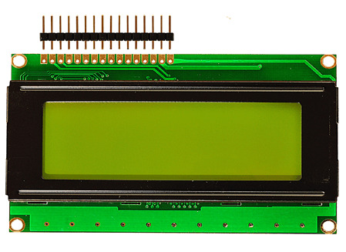

Fig 5.10: LCD Module

Features:

* Character LCD 20x4
* 5x8 dots includes cursor
* Built-in controller (RW1063 or Equivalent)
* +5V power supply (Also available for +3V)
* Negative voltage optional for +3V power supply
* 1/16 duty cycle
* LED can be driven by PIN1, PIN2, PIN15, PIN16 or A and K
* Interface: WH2004G - 6800, WH2004G1 - SPI, WH2004G2 - I2C.

**5.5 SOFTWARE DESCRIPTION**

Two software platforms are used for the implementation. Arduino IDE is used for programming the NodeMcu microcontroller. Application built using Blynk platform is used to view the nearby vehicles and infrastructure elements.

**5.5.1 ARDUINO IDE**

The Arduino [integrated development environment](https://en.wikipedia.org/wiki/Integrated_development_environment) (IDE) is a [cross-platform](https://en.wikipedia.org/wiki/Cross-platform) application (for [Windows](https://en.wikipedia.org/wiki/Windows), [macOS](https://en.wikipedia.org/wiki/MacOS" \o "MacOS), [Linux](https://en.wikipedia.org/wiki/Linux)) that is written in the programming language [Java](https://en.wikipedia.org/wiki/Java_(programming_language)). It originated from the IDE for the languages [Processing](https://en.wikipedia.org/wiki/Processing_(programming_language)) and [Wiring](https://en.wikipedia.org/wiki/Wiring_(development_platform)). It includes a code editor with features such as text cutting and pasting, searching and replacing text, automatic indenting, [brace matching](https://en.wikipedia.org/wiki/Brace_matching), and [syntax highlighting](https://en.wikipedia.org/wiki/Syntax_highlighting), and provides simple one-click mechanisms to compile and upload programs to an Arduino board. It also contains a message area, a text console, a toolbar with buttons for common functions and a hierarchy of operation menus [20].

The Arduino IDE supports the languages [C](https://en.wikipedia.org/wiki/C_(programming_language)) and [C++](https://en.wikipedia.org/wiki/C%2B%2B) using special rules of code structuring. The Arduino IDE supplies a [software library](https://en.wikipedia.org/wiki/Software_library) from the [Wiring](https://en.wikipedia.org/wiki/Wiring_(development_platform)" \o "Wiring (development platform))project, which provides many common input and output procedures. User-written code only requires two basic functions, for starting the sketch and the main program loop, that are compiled and linked with a program stub main() into an executable [cyclic executive](https://en.wikipedia.org/wiki/Cyclic_executive) program with the [GNU toolchain](https://en.wikipedia.org/wiki/GNU_toolchain), also included with the IDE distribution.

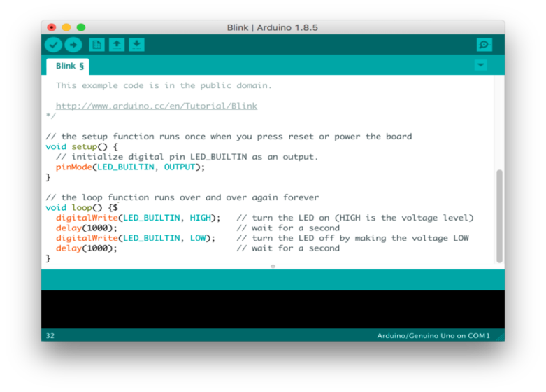

Fig 5.11: Arduino IDE

**5.5.2 BLYNK**

Blynk is a Platform with iOS and Android apps to control Arduino, Raspberry Pi and the likes over the Internet. It’s a digital dashboard where you can build a graphic interface for your project by simply dragging and dropping widgets. It’s really simple to set everything up and you'll [start tinkering](http://www.blynk.cc/getting-started) in less than 5 minutes [21].

Blynk is not tied to some specific board or shield. Instead, it's supporting hardware of your choice. Whether your Arduino or Raspberry Pi is linked to the Internet over Wi-Fi, Ethernet or this new ESP8266 chip, Blynk will get you online and ready for the **Internet of Your Things**.

**5.5.3 PYTHON**

Python is an [interpreted](https://en.wikipedia.org/wiki/Interpreted_language) [high-level programming language](https://en.wikipedia.org/wiki/High-level_programming_language) for [general-purpose programming](https://en.wikipedia.org/wiki/General-purpose_programming_language). Created by [Guido van Rossum](https://en.wikipedia.org/wiki/Guido_van_Rossum) and first released in 1991, Python has a design philosophy that emphasizes [code readability](https://en.wikipedia.org/wiki/Code_readability), notably using [significant whitespace](https://en.wikipedia.org/wiki/Significant_whitespace). It provides constructs that enable clear programming on both small and large scales. Python features a [dynamic type](https://en.wikipedia.org/wiki/Dynamic_type) system and automatic [memory management](https://en.wikipedia.org/wiki/Memory_management). It supports multiple [programming paradigms](https://en.wikipedia.org/wiki/Programming_paradigm), including [object oriented](https://en.wikipedia.org/wiki/Object-oriented_programming), [imperative](https://en.wikipedia.org/wiki/Imperative_programming), [functional](https://en.wikipedia.org/wiki/Functional_programming) and [procedural](https://en.wikipedia.org/wiki/Procedural_programming), and has a large and comprehensive [standard library](https://en.wikipedia.org/wiki/Standard_library).

Python interpreters are available for many [operating systems](https://en.wikipedia.org/wiki/Operating_system). [Python](https://en.wikipedia.org/wiki/CPython), the [reference implementation](https://en.wikipedia.org/wiki/Reference_implementation) of Python, is [open source](https://en.wikipedia.org/wiki/Open_source) softwareand has a community-based development model, as do nearly all of its variant implementations. Python is managed by the non-profit [Python Software Foundation](https://en.wikipedia.org/wiki/Python_Software_Foundation).

Advantages:

The Python language has diversified application in the software development companies such as in gaming, web frameworks and applications, language development, prototyping, graphic design applications, etc. This provides the language a higher plethora over other programming languages used in the industry. Some of its advantages are-

* **Extensive Support Libraries**

It provides large standard libraries that include the areas like string operations, Internet, web service tools, operating system interfaces and protocols. Most of the highly used programming tasks are already scripted into it that limits the length of the codes to be written in Python.

* **Integration Feature**

Python integrates the Enterprise Application Integration that makes it easy to develop Web services by invoking COM or COBRA components. It has powerful control capabilities as it calls directly through C, C++ or Java via Python. Python also processes XML and other markup languages as it can run on all modern operating systems through same byte code.

* **Improved Programmer’s Productivity**

The language has extensive support libraries and clean object-oriented designs that increase two to tenfold of programmer’s productivity while using the languages like Java, VB, Perl, C, C++ and C#.

* **Productivity**

With its strong process integration features, unit testing framework and enhanced control capabilities contribute towards the increased speed for most applications and productivity of applications. It is a great option for building scalable multi-protocol network applications.

Applications:

* [3D CAD/CAM](https://wiki.python.org/moin/Applications#A3D_CAD.2FCAM)
* [Audio/Video Applications](https://wiki.python.org/moin/Applications#Audio.2FVideo_Applications)
* [Console Applications](https://wiki.python.org/moin/Applications#Console_Applications)
* [Enterprise Applications](https://wiki.python.org/moin/Applications#Enterprise_Applications)
* [File Formats](https://wiki.python.org/moin/Applications#File_Formats)
* [Image Applications](https://wiki.python.org/moin/Applications#Image_Applications)
* [Internet Applications](https://wiki.python.org/moin/Applications#Internet_Applications)
* [Mobile Applications](https://wiki.python.org/moin/Applications#Mobile_Applications)
* [Office Applications](https://wiki.python.org/moin/Applications#Office_Applications)
* [Personal Information Managers](https://wiki.python.org/moin/Applications#Personal_Information_Managers)
* [Science and Education Applications](https://wiki.python.org/moin/Applications#Science_and_Education_Applications)
* [Software Development](https://wiki.python.org/moin/Applications#Software_Development)
* [System Administration Applications](https://wiki.python.org/moin/Applications#System_Administration_Applications)
* [X-Window Manager](https://wiki.python.org/moin/Applications#X-Window_Manager)
* [Unclassifie](https://wiki.python.org/moin/Applications#Unclassified)d

**CHAPTER – 6**

**IMPLEMENTATION OF V2X COMMUNICATION**

The figure 6.1 shows the flow chart of V2X communication. This flow chart represents only V2V and V2I functionality.

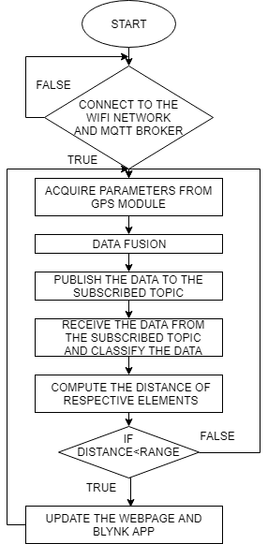

Fig 6.1: Flow chart of V2X communication

First, connect the device (NodeMcu or ESP8266) to the Wi-Fi network and MQTT broker. If not connected, the device will undergo reset. Once the GPS module starts receiving signal from satellites, fuse the acquired parameters from the GPS module such as latitude, longitude, speed and direction of heading into a string. Publish the fused data to the subscribed topic using MQTT broker. Simultaneously, receive the data from different V2X elements and classify them based on the first few characters of the message payload. Compute their respective distance and if the distance falls within the range, update the webpage and blynk app.

The information regarding infrastructure elements is displayed on LCD module. This information comprises of message from the respective infrastructure element and the distance of that element from the user’s vehicle.

The figure 6.2 shows the flow chart of V2P functionality and also shows how video processing and image processing are used to detect pedestrians on video.

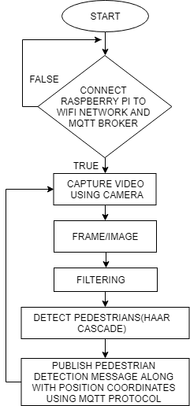

Fig 6.2: V2P flow chart

First, connect the Raspberry pi to wifi network and MQTT broker. After connection, capture video using camera and then convert the video into frames. Filter the frames using image processing. Detect the pedestrians on video and draw rectangular boxes around them. Publish this pedestrian detection message along with position coordinates of the juncture to MQTT broker such that nearby vehicles approaching that juncture is alerted about the presence of pedestrians ahead.

Raspberry pi is also responsible for storing all the published data into log file such that necessary computations can be performed on the data for analytics purpose. Figure 6.3 shows the code snippet where all the vehicular data and infrastructure elements data are being stored on datalog.txt and infalog.txt respectively.

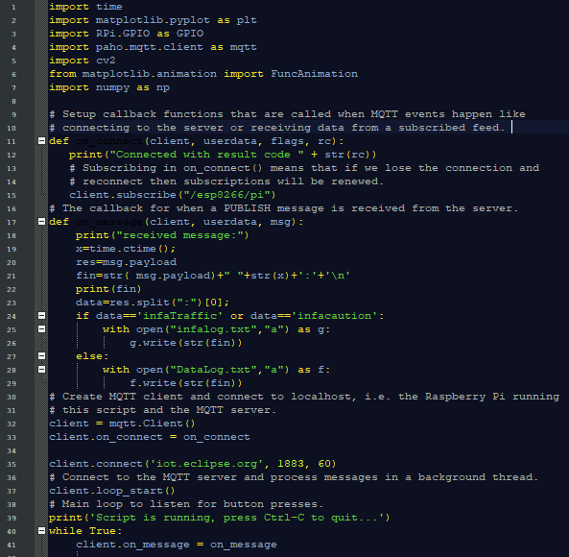

Fig 6.3: Code snippet for storing V2X elements data flow

Figure 6.4 shows how the data is stored in datalog.txt. The data stored contains car name, latitude, longitude (position of car), speed, direction of heading, time at which the data is sent and the time at which the data is received.

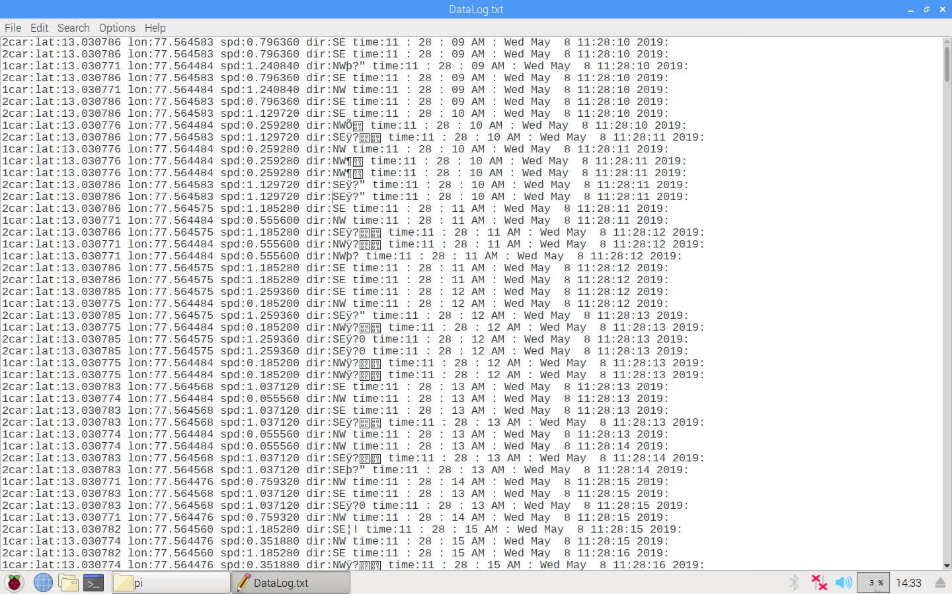

Fig 6.4: Vehicular data stored in datalog.txt

Figure 6.5 shows how the infrastructure elements data is stored in infalog.txt. The data stored contains message or status of that infrastructure element, position coordinates (latitude and longitude) and the time at which it is received.

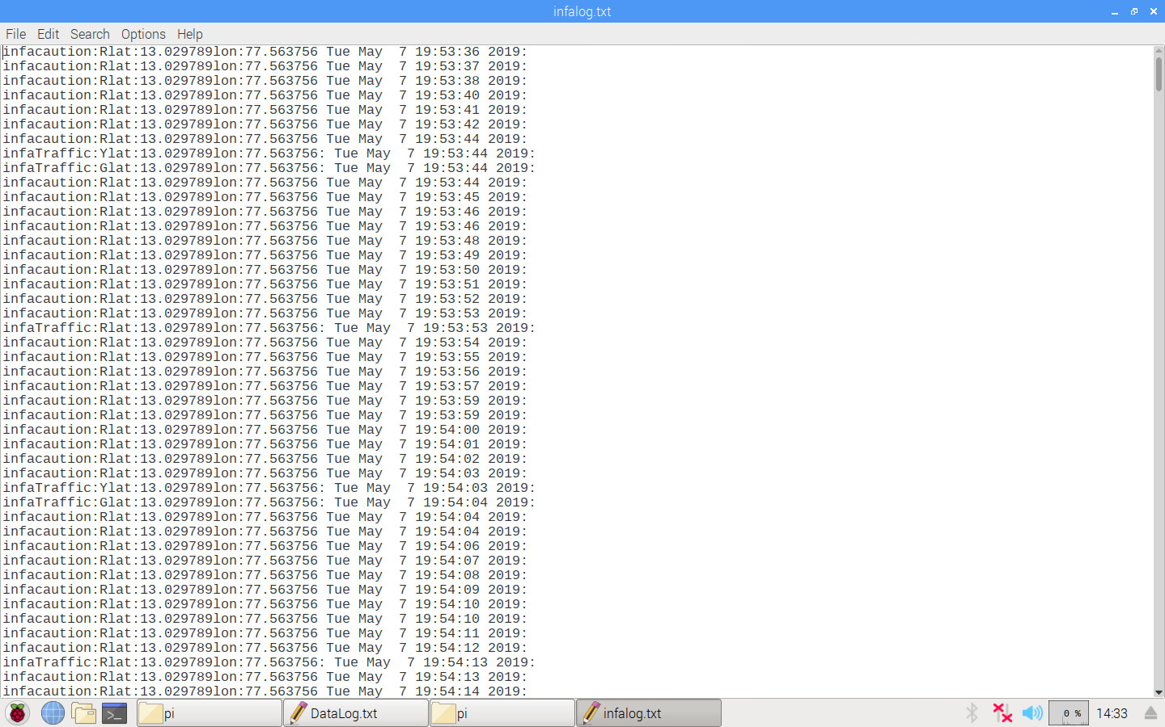

Fig 6.5: Infrastructure elements data stored in infalog.txt

Figure 6.6 shows the code snippet of V2P functionality using video processing. Computer vision2 library is used to perform image processing functions. First the video is captured using camera or a stored video can be used. The video is first converted into frames and then resized. The resized frames are then converted into gray images/frames using image processing. Rectangular boxes are drawn around pedestrians if detected and message is published along with its position coordinates to any nearby vehicles using MQTT protocol.

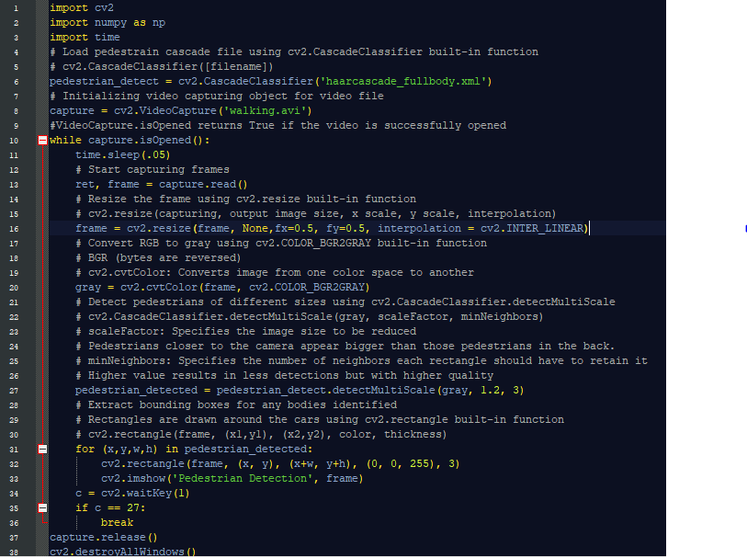

Fig 6.6: Code snippet of V2P functionality

Figure 6.7 shows the code snippet for plotting graphs using the stored data in datalog.txt. The data stored here is used to determine how many vehicles are present at a particular instant of time. This helps in analysing the traffic conditions in road network. Using the time at which the data is sent and received, latency of the V2X system can be determined.

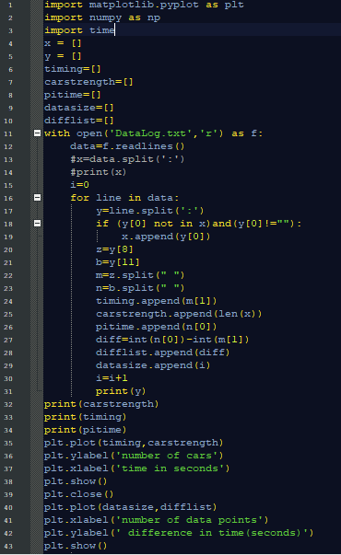

Fig 6.7: Code snippet for plotting graphs

The figure 6.8 shows the hardware implementation of V2X communication. The main controllers used here are NodeMCU/ESP8266 and raspberry pi. NodeMCU is used for transmitting the messages acquired by the GPS module. LCD module is used to display all the information received. An I2C module is used to convert serial data into parallel form in order to display the information in LCD.

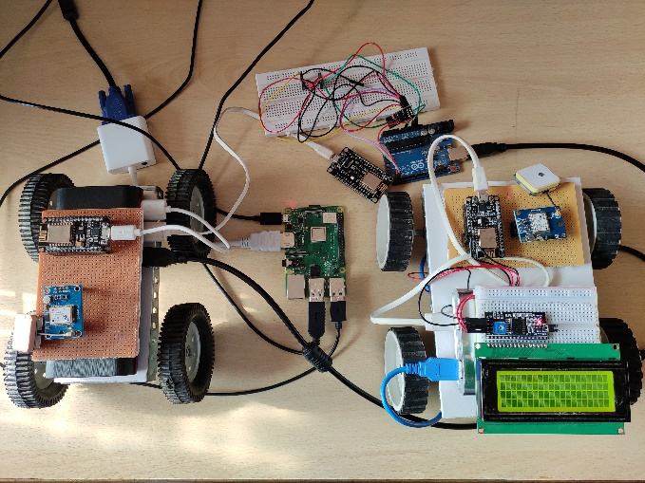

Fig 6.8: Hardware Implementation of V2X communication system

**CHAPTER 7**

**RESULTS AND DISCUSSION**

The V2X model was analyzed in real time scenario by conducting test runs to determine the range and accuracy of the design. Data compiled over multiple trials was examined and the following results were obtained. Figure 7.1 shows the Blynk application on mobile device which uses map widget to plot V2X elements and also shows necessary information such as message or status of infrastructure elements. It also provides easier access of information to the user.

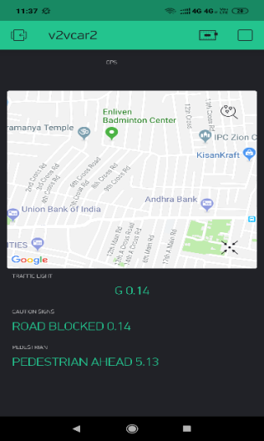

Fig 7.1: Blynk application on mobile device

**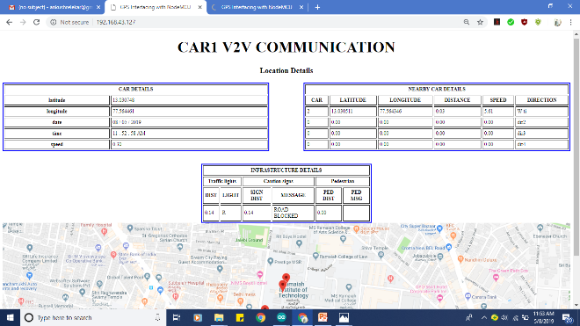**

Fig 7.2: Car1 v2v communication

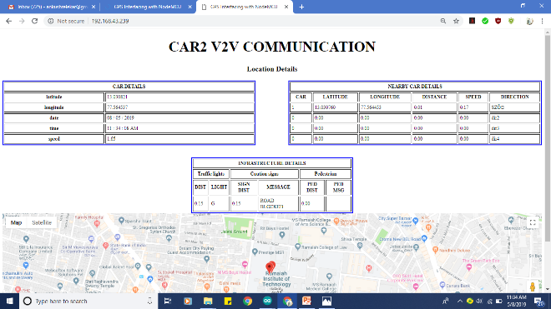

Fig 7.3: Car2 v2v communication

A webpage consisting of car details, infrastructure details and nearby car details with respect to car1 and car2 is summarized in Fig 7.2 and Fig 7.3. Google maps indicating the location of all the above details with an accuracy of ±2.5m with real time updates is displayed. The webpage consists of three tables. The first table shows the details of the car such as position coordinates, speed, date and time. The second table shows the nearby vehicle details such as its name, position coordinates, speed, direction of heading and distance from the user’s vehicle. The third table shows infrastructure details such as traffic light status, caution sign message, pedestrian details and the distance of these elements from user’s vehicle.

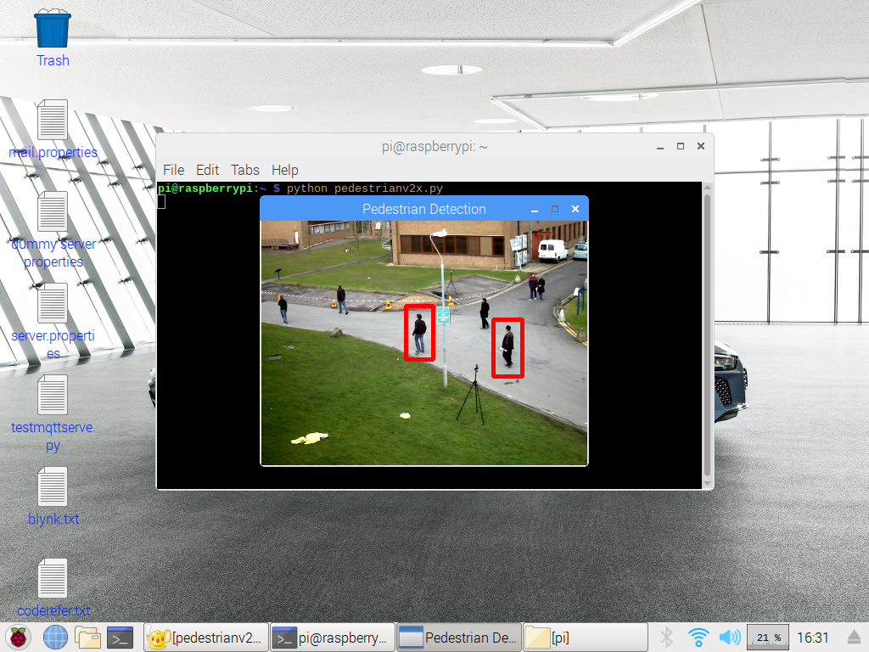

Fig 7.4: V2P using video processing

Vehicle to pedestrian (V2P) functionality is implemented by using raspberry pi which uses video processing to detect any pedestrians in a particular juncture as shown in figure 7.4. Message regarding their presence is alerted to the vehicles approaching that particular juncture using MQTT protocol. The message also contains position coordinates of the juncture using which distance can be calculated and the coordinates can be plotted on map.

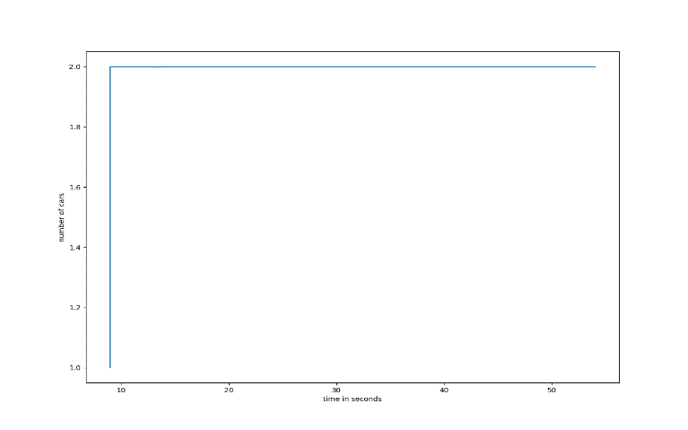

Fig 7.5: Number of cars recorded over a period of time

Using the data stored in raspberry pi, graphical representation of number of cars present in the grid at any particular time instant is obtained over certain period of time. In this particular instance data is compiled using two cars.

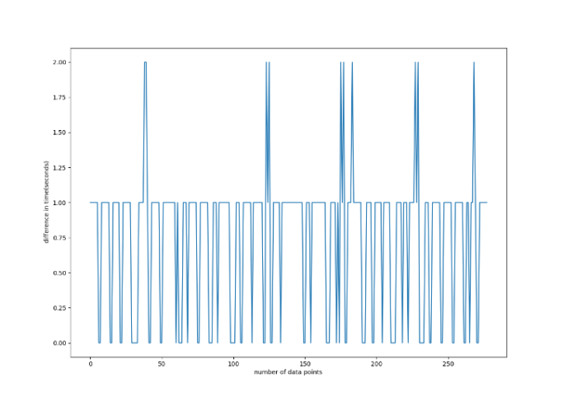

Fig 7.6: Number of data points versus time elapsed

Graphical representation about the number of data points acquired with respect to time elapsed between transmitted and received information is depicted. This plot represents the difference in time between transmission and reception of data points. Data recorded in raspberry pi is used for this graphical representation. Majority of the data points fall in the time difference of 0.0s to 1.0s. This conveys the latency with which the model operates.

**CHAPTER 8**

**CONCLUSION AND FUTURE SCOPE**

The V2X model incorporating V2V, V2I and V2P functionalities establishing seamless connectivity between vehicles, infrastructure elements and pedestrians across the entire road network was successfully implemented. V2V communication was established using two vehicles wherein position of the vehicle on the road at a particular instant with an accuracy of ±2.5m was achieved. Also speed of the vehicle, direction in which it is headed as well as information regarding nearby vehicles is conveyed to the operator of the vehicle. V2I functionality which combines information from road infrastructure entities with vehicles is implemented. This provides precise knowledge of the trafﬁc situation across the entire road network. In addition to this, pedestrian safety through real time analysis of their movements across intersections and pedestrian crossings is fulfilled using V2P functionality.

**1.3 Applications:**

* [Forward collision warning](https://en.wikipedia.org/wiki/Collision_avoidance_system)
* [Lane change warning](https://en.wikipedia.org/wiki/Lane_departure_warning_system)/blind spot warning
* Emergency electric brake light warning
* Intersection movement assist
* [Emergency vehicle](https://en.wikipedia.org/wiki/Emergency_vehicle) approaching
* Road work warning
* Stop sign violation
* Car breakdown warning
* Regulatory and contextual speed limits
* Traffic info and recommended itinerary

**10.1 CHALLENGES AND DRAWBACKS OF V2X COMMUNICATION**

* As vehicles in V2X are connected to internet, they are prone to hacking. Hackers can access and control the vehicle.
* Privacy of the owners and users of the vehicles are major concern. This is due to leakage of information such as vehicle location, daily routine, frequently used apps etc. The hacked information can be used for unauthorized purposes. These can also be used by organizations and government agencies.
* Autonomous driver system can cause fatal consequences during failure of the system.
* Malfunctioning of cars or sensors or networks lead to incorrect data. This leads to faulty communications.

**10.2 FUTURE SCOPE**

* V2X architecture can be combined with ADAS (Advanced driver-assistance systems) technology to enhance vehicle systems for safety and better driving.
* V2X Communications should make sure the communication reliability, safety of the whole and location accuracy. New communications technologies, system software, chips, GPS modules need to improve and develop to make sure the quality of V2X Communications.
* V2X along with adaptive cruise control can be used to track nearby vehicles by using radar and adjust its speed accordingly. Lane departure warning systems seen in some luxury cars can notify you if your car is drifting out of its lane. Both of these high-tech features give drivers a greater awareness of their surroundings.

**REFERENCES**

1. Dr. S.N. Pradhan , Mrs. Vaishali D. Khairnar, Nirma University, “V2V communication survey- (Wireless Technology)” , IJCTA , JAN-FEB 2012, , Vol.3 (1), 370-373
2. Irshad Ahmed Abbasi and Adnan Shahid Khan, University Malaysia Sarawak, “A Review of Vehicle to Vehicle Communication Protocols for VANETs in the Urban Environment”, 31January 2018, [mdpi, journal](http://www.mdpi.com/journal), futureinternet, vol.10(2), 14
3. Izwan Idris, “Real-time vehicle monitoring and positioning using MQTT for reliable wireless connectivity”, Faculty of Science and Engineering, Queensland University of Technology 2017, QUT Thesis, 30 May 2017
4. Alanazi Yunus Ali S, Alsalem Hussain, “Vehicle Talks to IoT for Better Driving Experience”, Kogakuin University, Tokyo, Japan, Open Science Journal, 11-01-2011, vol.3
5. [Laurens Hobert](https://ieeexplore.ieee.org/author/37085428056), [Andreas Festag](https://ieeexplore.ieee.org/author/37085410374), [Ignacio Llatser](https://ieeexplore.ieee.org/author/37704099800), [Luciano Altomare](https://ieeexplore.ieee.org/author/37085725044), [Filippo Visintainer](https://ieeexplore.ieee.org/author/38072354700), [Andras Kovacs](https://ieeexplore.ieee.org/author/37662711200), “Enhancements of V2X communication in support of cooperative autonomous driving”, [IEEE Communications Magazine](https://ieeexplore.ieee.org/xpl/RecentIssue.jsp?punumber=35) ( Volume: 53 , [Issue: 12](https://ieeexplore.ieee.org/xpl/tocresult.jsp?isnumber=7355551) , Dec. 2015 )
6. Tobias Queck, Bjorn Schunemann, Ilja Radusch, Prof. Christoph Meinel, “Realistic Simulation of V2X Communication Scenarios”,[2008 IEEE Asia-Pacific Services Computing Conference](https://ieeexplore.ieee.org/xpl/mostRecentIssue.jsp?punumber=4780614), 9-12 Dec. 2008.
7. [Muntaser A. Salman](https://www.mdpi.com/search?authors=Muntaser%20A.%20Salman&orcid=0000-0002-8347-2729), Suat Ozdemir, [Fatih V. Celebi](https://www.mdpi.com/search?authors=Fatih%20V.%20Celebi&orcid=), “Fuzzy Traffic Control with Vehicle-to-Everything Communication”, Department of Information Systems, College of Computer Sciences and Information Technology, University of Anbar, 55431 Baghdad, 55 Ramadi, Anbar, Iraq, 27 January 2018, vol.18(2), 368
8. [Debalina Barik](https://ieeexplore.ieee.org/author/37547267700); [Manik Mondal](https://ieeexplore.ieee.org/author/37544154700), “Object identification for computer vision using image segmentation”, [2010 2nd International Conference on Education Technology and Computer](https://ieeexplore.ieee.org/xpl/mostRecentIssue.jsp?punumber=5508190),22-24 June 2010.
9. Hitoshi Hayakawa, “Demo: Vehicle-to-everything middleware supporting multiple access technologies for improving network coverage”,[2017 IEEE Vehicular Networking Conference (VNC)](https://ieeexplore.ieee.org/xpl/mostRecentIssue.jsp?punumber=8267164)27-29 Nov. 2017.

# [Tien Viet Nguyen](https://ieeexplore.ieee.org/author/37086320543), [Patil Shailesh](https://ieeexplore.ieee.org/author/37086322527), [Baghel Sudhir](https://ieeexplore.ieee.org/author/37086321504), [Gulati Kapil](https://ieeexplore.ieee.org/author/37086324054), [Libin Jiang](https://ieeexplore.ieee.org/author/37086325013), [Zhibin Wu](https://ieeexplore.ieee.org/author/37085749327), [Durga Malladi](https://ieeexplore.ieee.org/author/37296823900), [Junyi Li](https://ieeexplore.ieee.org/author/37715748500), “A comparison of cellular vehicle-to-everything and dedicated short range communication”,[2017 IEEE Vehicular Networking Conference (VNC)](https://ieeexplore.ieee.org/xpl/mostRecentIssue.jsp?punumber=8267164) 27-29 Nov. 2017, pg.no 101-108.

# WHO road traffic injuries report. [Online].Available: https://www.who.int/news-room/fact-sheets/detail/road-traffic-injuries

# Road accidents statistic in India. [Online].Available: https://sites.ndtv.com/roadsafety/important-feature-to-you-in-your-car-5/

# Siemens Vehicle-to-X communication technology. [Online].Available: http://www.middleeast.siemens.com/pool/news\_press/siemens-vehicle-to-x-communication-technology-infographic.pdf

1. SotA Research with regard to Car2X Communication, Cloud and Network Middleware and corresponding Security Concepts, Appstacle.
2. ESP8266 NodeMCU. [Online].Available: https://en.wikipedia.org/wiki/NodeMCU
3. Raspberry Pi 3 B+. [Online].Available: https://en.wikipedia.org/wiki/Raspberry\_Pi
4. NEO-6M GPS module. [Online].Available: http://wiki.sunfounder.cc/index.php?title=Ublox\_NEO-6M\_GPS\_Module
5. LCD module. [Online].Available: http://www.lumisense.in/pdfs/20-4%20LCD.pdf
6. Arduino IDE. [Online].Available: https://en.wikipedia.org/wiki/Arduino
7. Blynk. [Online].Available: <https://www.blynk.cc/>